Office of the Vice President for Research
Environmental Health & Safety

Employee / Occupational Safety

Electrical Safety for Principal Investigators (PIs), Laboratory & Shop Supervisors, and Students

Electrical Service and Equipment
Most likely your projects and experiments rely on electricity to operate. Essential electrical equipment in laboratories can include: hot plates, stirrers, vacuum pumps, electrophoresis apparatus, lasers, heating mantles, ultrasonicators and power supplies. Other special equipment noted in UVa shops are saws, lathes, milling machines, paper beaters and dye vats. Building safety and infrastructure, such as lighting, heating, ventilation, fire alarms, and computers/communications as well as water and gas (which require pumps) all depend upon electrical power.
Electricity that powers these pieces of equipment and systems is provided by the building's electrical service and distributed through wiring into breaker panels, disconnect boxes and wall receptacles. Typically, electrical equipment is hooked up by cord and plug into a wall receptacle or hard wired into a disconnect or other disconnecting means such as a breaker panel. Please note that any equipment hardwired into the facility's electrical service system (such as a breaker panel), must be serviced or repaired by a qualified and licensed electrician.
See the University’s Electrical Safety Program for Facilities Management for information on University authorized personnel and procedures, to perform electrical work on buildings’ electrical service systems
Frequently Asked Questions (FAQ):
Q1. Who is at risk for electrical hazards and what are the hazards?
Q2. What are harmful levels of electrical current that can lead to injury and electrocution?
Q3. In my role as manager/supervisor what should I do to prevent accidental contact with electricity?
Q4. Does the University have requirements I need to follow if I bring electrical equipment or machinery into my lab or shop?
Q5. What steps can I implement to prevent electrical hazards from occurring?
Q6. How can I avoid fire hazards around electrical equipment?
Q7. How do I avoid electrical hazards around water?
Q8. Do I need to maintain clearance around the facility's electrical service equipment (example an Electrical Service Panel) in my work area?
Q9. Is it necessary to unplug electrical equipment first before I work on it?
Q10. Do I need to be trained and follow procedures if I have to apply power to my equipment for diagnostic testing?
Q11. What are relevant electrical protective equipment, tools and methods to consider?
Q12. I may assemble, modify, install or design electronic or electrical equipment in my lab. What regulations are applicable for me to follow?
Q13. Are there any special precautions to take with equipment hardwired into a disconnect box?
Q14. What other resources are available for electrical safety work practices?
Q15. Who can I contact at UVa for additional assistance and service?

Q1. Who is at risk for electrical hazards and what are the hazards?
Answer -- Electricians may first come to mind but no one is immune; anyone that operates electrical equipment is at risk. That puts you at risk! In fact, you probably cannot complete your experiments or projects without using electricity.
What are the hazards?
- The National Safety Council reports:
  - One of the leading causes of workplace fatalities (estimated 1,000 per year) is from electrical shock;
  - Approximately 30,000 non-fatal electrical shock accidents occur each year.
  - The majority of hospital admissions due to electrical accidents are from arc flash burns and not from shock. Each year over 2,000 people are admitted to hospital burn centers because of severe arc flash burns.

Q2. What are harmful levels of electrical current that can lead to injury and electrocution?
Answer -- The Occupational Safety & Health Administration (OSHA) and National Electrical Code recognize the serious shock and fire hazards inherent in electrical equipment that operates at 50 volts and higher. This voltage level and higher can cause dangerous levels of current to flow through our bodies if we accidentally become part of the electrical circuit. The effects of harmful current range from painful tingling, inability to let go of the electrical object due to muscular contraction, burns to internal tissue and organs, ventricular fibrillation and death.
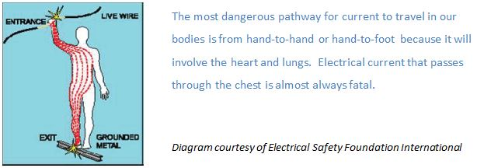
The following chart is from the National Safety Council's electrical safety training module Prevention Strategies for Electrical Hazards. This module is one of many excellent safety training resources available through OSHA's Susan Hardwood Training Grant program.
Current | Reaction
1 Milliampere | Perception level, a faint tingle.
5 Milliamperes | Slight shock felt, not painful, but disturbing. Average individual can let go. Strong involuntary reactions to shocks in this range can lead to injuries.
6-25 Milliamperes (women) | Painful shock. Muscular control is lost.
9-30 Milliamperes (men) | Freezing current or "let go" range.
50-150 Milliamperes | Extreme pain. Respiratory arrest. Severe muscular contractions, Individual cannot let go. Death is possible.
1,000-4,300 Milliamperes | Ventricular fibrillation (the rhythmic pumping action of the heart ceases). Muscular contraction and nerve damage. Death is most likely.
10,000+ Milliamperes | Cardiac arrest. Severe burns. Probable death.
Source: W.B. Kouwenhoven, "Human Safety and Electric Shock", Electrical Safety Practices, Monograph 112, Instrument Society of America, (93) | Source: Prevention Strategies for Electrical Hazards, 2008 National Safety Council
The University is committed to follow OSHA and NEC regulations to ensure the safety of our personnel, students and institution. Look for electrical information, such as operating current (amps) and voltage, on the manufacturers label posted on your electrical equipment or appliance.

Q3. In my role as manager/supervisor what should I do to prevent accidental contact with electricity?
Answer -- Recognize and anticipate potential hazards and plan accordingly to prevent electrical contact risks. Contact EHS at 982-4911 if you need assistance to perform an electrical safety hazard evaluation
Failure to address electrical hazards in your area of responsibility can result in electrical shock, electrocution (fatal shock can occur at even low voltages 50-120 volts), catastrophic burns including death from burns because of an electrical arc flash incident or an explosion. Also, keep in mind that misuse or errors in installation of electrical equipment can destroy very expensive equipment, even other properly installed equipment on the same electrical line.
EHS encourages every individual at UVa to learn and work in a safe environment. We depend on you in your leadership role as PI, lab and shop managers to provide safe environments by:
- Identifying and documenting hazards;
- Anticipating hazards (asking the "what ifs") and correcting hazards as they are found;
- Developing Standard Operating Procedures (SOP) to reliably prevent hazards and;
- Provide relevant training to individuals at risk.

Q4. Does the University have requirements I need to follow if I bring electrical equipment or machinery into my lab or shop?
Answer -- Yes! See the summary below:
- When departments have electrical equipment installed or brought into University-owned facilities, the department should provide oversight for safe use and condition of the equipment. Departments are responsible for training staff personnel and students in the proper use and maintenance of the equipment to avoid electrical contact injuries. Oversight and training needs to incorporate the equipment manufacturer's operation and maintenance instructions.
- Guidelines have been established in Facilities Management’s comprehensive Electrical Safety Program which provide in depth guidance to mitigate inherent electrical risks. If you have questions, contact EHS at 982-4911 for assistance.
- Facilities Management requires building permits for construction and renovations that will involve the following: removal, addition, alteration or relocation of electrical systems. Electrical systems are considered integral to the facility itself. Examples include electricity that is hardwired in the facility like wall receptacles, lighting and electrical breaker panels. The intent of building permits is to meet compliance with all applicable building codes, the National Electrical Code and to ensure the safety of the facility and building occupants.
- Facilities Management can advise on the electrical services that will be needed to accommodate the electrical demand for equipment installations.

Q5. What steps can I implement to prevent electrical hazards from occurring?
Answer -- Take time to implement the following electrical safety guidelines. Your life and the individuals for whom you are responsible may depend on it.
Extension Cords - Avoid the use of extension cords and do not use them as means of permanent wiring. Avoid stringing cords across walkways which can create significant trip hazards. Improper use of extension cords can create fire risks. They can be overloaded with too many objects which will cause the cord to overheat. They can be misused with high wattage appliances, drawing too much current and cause the cord to overheat. These are some of the reasons why Building and Fire Prevention Codes and the University do not allow them as a means of permanent wiring.
- Extension cords used as permanent wiring will be designated as a violation when noted during our routine Fire Safety Inspections and Lab Consultations. Please pay heed now and implement a safer way to provide electrical service to your equipment. This may require additional electrical services. You can call Facilities Management Service Desk to make your request.
Inspect Power Cords - Routinely inspect the equipment power cord to assure the wiring's protective insulation is intact. Look for any cracks, nicks or any obvious signs of damage. Environments with elevated levels of ozone (such as UV lights or electrical motors) can lead to rapid deterioration of the plastic wiring insulation.
Use Grounded Three Pronged Plug Ends - All laboratory and shop electrical equipment should be grounded with a three pronged plug end. Make sure the ground prong is in place and is not damaged. A ground prong is never allowed to be removed to accommodate older wall outlets that only have two prong openings. If you find equipment with a damaged or missing ground plug immediately remove it out of service.
- Check the prong end and make sure the wiring is not exposed from misuse such as pulling equipment out of the receptacle by the cord. This poor practice over time will cause damage.
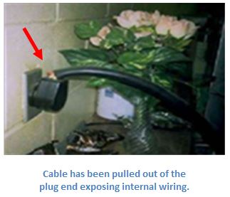
Damaged Electrical Equipment - Damaged electrical equipment needs to be immediately taken out of service and reported to the management responsible for getting the equipment repaired. Qualified individuals authorized by the department need to make repairs to damaged cords. You can also call Facilities Management Service Desk for help with damaged cords and are encouraged to do so.
Do Not Bypass Electrical Cover or Enclosures - Never remove electrical covers or enclosures on electrical equipment. They are provided to protect you from electrical contact hazards such as exposed wires or capacitors. The equipment manufacturer almost always has warning labels that warn you – DO NOT REMOVE COVER. Read and heed! Also, do not defeat equipment safety interlocks that are designed to shut down equipment when safety covers, guards or enclosures are removed.
Unplug Equipment Before Working On It - If you have to perform any type of work on the electrical equipment that can put you at risk of being injured by the operation of the equipment - Turn it off and unplug it first before you do the work activity.
If you get shocked seek medical attention - In the event of an electrical contact injury, always seek medical attention. This is advised even when you get a "tingle" shock. Older individuals can be at greater risk for a heart attack and should be monitored. After addressing the emergency determine if the equipment being used is at fault and if so, immediately remove from service so that no one else will get injured.
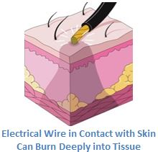

Q6. How can I avoid fire hazards around electrical equipment?
Answer -- You can take the following steps to help avoid fire risks around electrical equipment.
Power strips have limited use at the University. Power strips should be limited for equipment that operates at low currents (generally less than 800 watts) like computers, printers, and monitors.
- If you use power strips in your laboratory or shop they must be UL 1363 approved for overload protection. If you have any questions about using an approved power strip you should contact our EHS Fire Safety staff at 434-243-1711 or fire-safety@virginia.edu.
- Equipment and appliances that operate at higher currents (1,000 watts) must be plugged directly into the building's wall receptacles and never into a power strip. Power strips are limited in providing current overload protection that prevents overheating and a fire hazard. It is not possible to provide a complete list of appliances and equipment that operate at 1,000 watts or higher in a lab but here are some examples: Refrigerators, freezers, large centrifuges, sterilizers, vacuum pumps, water stills, hot plates, heat guns and microwaves. [Reference: CRC Handbook of Laboratory Safety]
- Never plug a power strip into another power strip. This is often referred to as "Daisy chaining". It is a very unsafe act and against Fire Code. The plug end of a power strip must always be plugged directly into a wall receptacle. Contact Facilities Management Service Desk if you need additional Electrical outlets.
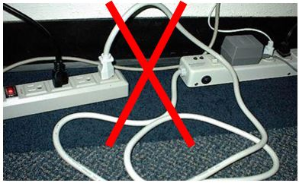
Do not continue to reset a Circuit Breaker that keeps shutting off ("tripping"). Do not reset a breaker that has tripped before determining the cause. Attempt to correct the problem first. It may be that too many appliances and equipment have overloaded the circuit. If your attempt to fix the problem is not successful, do not repeat attempts to reset the breaker. Continuing to reset a breaker that is tripping due to an overload or fault can cause it to explode. To avoid this situation contact Facilities Management Service Desk to correct the problem.
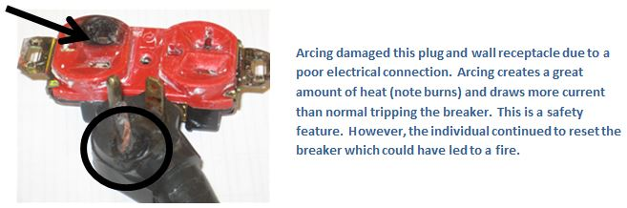
Avoid flammable materials, sparks or static charges around electrical sources. Avoid having open flammable or combustible materials near electrical power sources such as a wall receptacle. It is best to return these materials to the proper flammable storage location when not in use and always ensure containers are closed and sealed securely to avoid vapors. Contact EHS if you need assistance with flammable cabinets or other related information (434-982-4911).
- Avoid sources of sparks or static charges around receptacles. Princeton University EHS Services has helpful information about avoiding spark hazards with motor driven equipment (see circuit protection devices and motors).
- Consider using grounded timers on equipment with heating elements (i.e. water bath) to prevent overheating. A timer can help prevent a potential fire, smoke or other damages if you forget to turn the equipment off at the end of an experiment or the work day.

Q7. How do I avoid electrical hazards around water?
Answer -- Install a Ground Fault Circuit Interrupter (GFCI) on electrical receptacles located within six feet of a water source such as emergency equipment or a lab sink.
Be aware of working with electrical equipment near sinks, water baths, and emergency equipment in your area. The National Electrical Code (NEC) requires a GFCI to be installed in wall receptacles within six feet of a sink in residential areas. A GFCI shuts off the flow of current within milliseconds upon sensing a fault condition such as an electrical shock. This helps to prevent the shock victim from receiving a lethal amount of electricity. Following NEC's guidelines for sinks, if you have a water source within six feet of a receptacle that is not GFCI protected, call Facilities Management Service Desk for assistance.
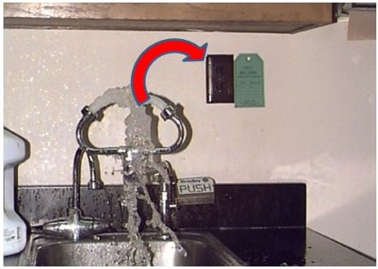
Another concern is water standing in puddles around electrical equipment or saturation of electrical equipment from flooding such as a leak in water cooled equipment or an activation of sprinklers. Do not attempt to unplug electrical equipment, instead cut off the electrical power at the breaker panel if you are able or contact Facilities Management for assistance. This is preferable so that the cause of flooding can be safely addressed as well as helping you troubleshoot any damage to your electrical equipment.

Q8. Do I need to maintain clearance around the facility's electrical service equipment (example an Electrical Service Panel) in my work area?
Answer -- Yes! You are required to maintain immediate access to electrical service equipment for repair and service work by electricians.
A common laboratory "fire code violation" is blocked access to electrical service equipment such as the Breaker Panel. In an emergency, Firefighters and qualified electricians need immediate access to this type of equipment.
A minimum of three feet of clearance is required in front and to the sides of the breaker panel. Marking tape can be very useful to remind people to keep this important area free of storage and clutter. It is also important for you to have safe working clearance around any equipment that you operate in your lab or shop.
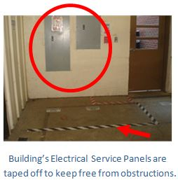

Q9. Is it necessary to unplug electrical equipment first before I work on it?
Answer -- Yes! It is best to unplug it first for your safety.
Your equipment may have a short or other malfunction and it is not sufficient to just cut off a power switch. One type of activity you may need to do on equipment is to change out parts. Not all activities can be anticipated and listed here so practice caution. If you "shut it down" and keep the plug under your control, (visible throughout the work activity until the work is complete) you have assured yourself a good measure of safety. You are advised to lock out the plug end with a protective cover and padlock if the work activity takes considerable time and if there is a chance you may not always have the cord and plug visually under your control.
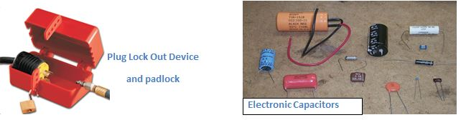
Always practice caution around capacitors. They can still hold a charge even when equipment has been unplugged. If any work has to be done around a capacitor it must be discharged first to assure all sources of electrical power are de-energized.

Q10. Do I need to be trained and follow procedures if I have to apply power to my equipment for diagnostic testing?
Answer -- Due to the inherent risks of electrical shock and potential for an electrical arc flash, only Qualified Personnel are authorized to perform diagnostic testing. To become qualified, personnel must attend the University’s electrical safety training to further understand inherent electrical hazards when performing diagnostic work and how to avoid them. Training will review electrical safety work practices and protective measures that must be used, to prevent electrical shock and burn injury hazards. In addition to this training, Personnel must be knowledgeable on the electrical system and equipment he or she will work on. Contact EHS Electrical Safety staff at 434-982-4911 for assistance to register for training and to perform electrical hazard evaluations.

Q11. What are the electrical safety protective measures generally used by Qualified Personnel?
Answer -- Qualified personnel use electrical insulated tools such as voltage test meters and electrical protective equipment (i.e. voltage rated gloves) to avoid electrical shock. Other personal protective equipment may be indicated based on the results of the electrical hazard evaluation. Contact EHS at 982-4911 to request assistance with an electrical hazard evaluation to identify the proper electrical protective equipment.
- Consult the Electrical Equipment Products and Testing Services for the types of insulating electrical protective equipment and testing requirements.
- Other protective equipment may include electrical insulated floor mats and blankets to cover conductive surfaces. Equipment shielding and isolation, to the extent feasible, is strongly recommended to prevent direct contact with energized conductors.
- Personnel must be knowledgeable on how to use diagnostic testing equipment; and follow the equipment manufacturer’s instructions and warnings, including calibration to verify accuracy and proper function if specified to do so.

Q12. I may assemble, modify, install or design electronic or electrical equipment in my lab. What regulations are applicable for me to follow?
Answer -- Please note that this FAQ is not able to adequately list all of the electrically related activities that researchers may perform in their labs. Electrical activities must meet the safety requirements of the National Electrical Code (This Code addresses electrical installations for the safety of persons and property); OSHA 1910.331-.334 Safety Related Work Practices and NFPA 70E Standard for Electrical Safety in the Workplace.
These regulations cover the Employer's responsibilities to provide safety for individuals in the workplace and at UVa that includes our students. Please review the Facilities Management Electrical Safety Program.
The following resource is a document published by OSHA Office of Training and Education. It references OSHA's Electrical Standard and NFPA 70-National Electrical Code. Information included: examination, installation and use of electrical equipment, grounding electrical equipment, ground fault circuit interrupters and flexible cords and cables.

Q13. Are there any special precautions to take with equipment hardwired into a disconnect box?
Answer -- Yes! When you shut off electrical power by turning off a Disconnect Switch. High amperage equipment or machinery such as 30, 40 and 50 Amps is generally hard wired into a disconnect box, special precautions must be taken into account.
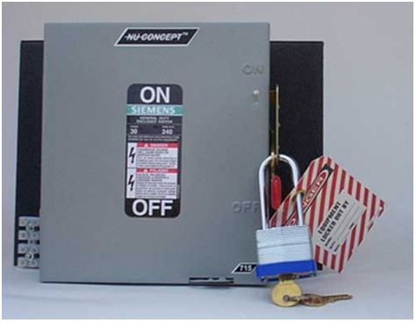
Personnel responsible for "hard wired" equipment in a lab or a shop, may need to occasionally work on the equipment. First steps include becoming qualified to perform this work task and understand how to identify and safely shut down all energy sources powering the equipment. Shutting down and securing power sources is referred to as Lock out Tag out (LOTO). To become qualified, personnel must participate in the University’s LOTO training and Electrical Safety training. Contact EHS at 982-4911 for assistance with training and identifying applicable LOTO precautions and procedures.
Four (4) safety issues to note are:
- Personnel are not to perform a repair or service that involves working on energized conductors or; at any time coming into accidental contact with energized conductors that may become exposed if any electrical safety guard, shield or enclosure is removed. This type of work needs to be referred to: a qualified and licensed electrician (i.e. Facilities Management), or an equipment manufacturers' service technician. These individuals are authorized through special training and knowledge to perform work on equipment when it is energized or there is a potential risk of coming into contact with any of the electrical systems that can be energized.
- Personnel in the shop or lab must be qualified to perform the intended Lock Out procedure and assure all hazardous energy sources are shut off prior to doing the work. Other types of hazardous energy, in addition to electrical, include: hydraulic, pneumatic, chemical, thermal and mechanical energy. Hazardous energy can also be stored such as in capacitors or when equipment has a sustained load (i.e. machinery or system components are suspended, blocked or chocked).
- A qualified individual must have documented training and be knowledgeable on the specific hazards inherent in the equipment, the LOTO procedure, and applicable LOTO devices to secure the equipment. For more information on safely locking out equipment, please review: Frequently Asked Questions for Lock Out Tag Out and the University's Lock Out Tag Out Program. You are also advised to follow the equipment manufacturer's operations and instruction manual.
- If the Lock Out procedure involves shutting the electrical power off at the disconnect switch, qualified lab or shop personnel must follow the bulleted safety precautions listed next. These precautions will help to assure his or her personal safety from any potential electrical arc hazard when activating the disconnect switch.
  - Safe procedures for shutting off the disconnect switch begins with wearing the right level of electrical personal protective equipment (PPE). PPE will help to prevent injuries if an electrical arc event occurs due to a faulty disconnect switch. This occurrence is expected to be minimal but you must be prepared and protected.
  - You will need to wear plastic frame safety glasses (no metal) or impact resistant safety goggles (preferable) to protect your face from any shrapnel. You will also need to use hearing protection to protect your ears from explosive noise. Wear a heavy leather glove on your left hand and a long sleeve 100% cotton shirt or lab coat to protect your skin from burns.
  - Do not wear any synthetic clothing such as rayon or polyester including fleece. These fabrics can exacerbate the level of burn injuries in the event of an electrical arc flash by embedding into the skin. This goes for what you are wearing underneath the long sleeve shirt or lab coat.
  - Donned in your PPE, use the "left hand rule" to throw the disconnect switch into the off position. Twist your face and torso away and use your left hand to turn the safety switch off. This helps to prevent a direct injury to the face and front of torso in the case of a sudden mechanical failure inside the disconnect box.
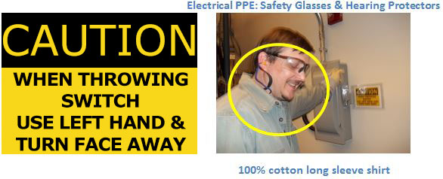
  - Next, operate the power switch of the equipment or machinery to verify the power is off. The electrical disconnect switch must be locked out by the authorized individual shutting off the power as well as any other authorized individual who will perform work on the equipment.
  - For more information on safely locking out equipment, please review: Frequently Asked Questions for Lock Out Tag Out and the University's Lock Out Tag Out Policy. Call the EHS Occupational Safety Specialist if you have any questions.
  - Remember! A qualified licensed electrician must perform services or repairs on electrical equipment where there is any risk of coming into contact with energized conductors.
  - If you need electrical service for your equipment, call the Facilities Management Service Desk.

Q14. What other resources are available for electrical safety work practices?
Answer -- The following compilation of web links is for electrical safety resources on best work practices and design. Resources include: electrical codes and standards as well as organizations and associations. These have been made available courtesy of National Institute of Building Sciences (NIBS). NIBS is the publisher of the Whole Building Design Guideline website. EHS hopes this information will be beneficial and provide relevant safety and health information on electrical related activities in the field and in the research laboratory.
- Relevant Electrical Codes and Standards
  - National Electrical Code (NEC) - NFPA 70 - The NEC is the accepted standard for protection of persons and property from electrical installations. Familiarization with NFPA 70 is a must for anyone having responsibility for design, installation or verifying and maintaining safe and compliant electrical systems. Information can be found through the NFPA website with a membership or printed and electronic versions of the code can be purchased from NFPA and other suppliers.
  - National Electrical Installation Standards (NEIS) - The NEIS gives definition to "neat and workmanlike manner" as required by the National Electrical Code. Each standard is submitted for approval by the American Standards Institute (ANSI).
  - Institute of Electrical and Electronics Engineers (IEEE) - IEEE has a National Electrical Safety Code that provides information on the installation, operation, and maintenance of electrical systems. The intent of the publication is the safeguarding of persons performing the work. Information, like the NEC, is available with IEEE membership or by buying a printed or electronic version of the code.
  - National Fire Protection Association (NFPA) – The NFPA is the definitive source for everything related to fire protection. The association has developed numerous standards that have been adopted by federal, state, and local jurisdictions as enforceable standards. The site has plenty of free information. More specific information is restricted to members only.

  - Occupational Health and Safety Administration (OSHA) – OSHA is the main governmental resource for effective safety practices. The website is a vast, readily accessible information resource with a thorough search engine.
    - Electrical safety training resources available through OSHA's Susan Hardwood Training Grant program
  - National Institute for Occupational Safety and Health (NIOSH) - NIOSH is similar in mission to OSHA but differs by the singular perspective that NIOSH is the federal agency responsible for the prevention of work related disease and injury.
- Organizations and Associations
  - Electrical Safety Foundation International (ESFI)
  - National Electrical Contractors Association (NECA)
  - National Electrical Manufacturers Association (NEMA)
  - National Safety Council (NSC)
  - National Society of Professional Engineers
  - Magazine article, Electrical Safety in the Lab

Q15. Who can I contact at UVa for additional assistance and service?
Environmental Health & Safety responds to requests for electrical safety regulatory compliance, provides assistance with safe work practices, and coordinates Electrical Hazard Analysis (EHA) as needed. Contact EHS at (434-982-4911).
Facilities Management requests for electrical repairs or service or; preventive maintenance & electrical project design and installations: Academic Facilities & Grounds (434-924-1777); Health System Facilities & Grounds (434-924-2267).
Request for Compliance to building codes including National Electrical Codes: Office of the University Building Official- https://oubo.virginia.edu/; (434-982-4621).
The Environmental Health and Safety Department wishes to recognize the following individuals for their helpful collaboration. Thank you all for your generous assistance.
- Facilities Management Staff: Sathish Anabathula, Associate Director and Will Evans, Engineering Associate, - Power & Light Division, Ed De Bary, Electrician and McCormick Zone Supervisor
- Chemistry Faculty: Kevin Lehmann, William R. Kenan, Jr., Professor Chemistry

