Respiratory Protection Program

TABLE OF CONTENTS
1. Record of Changes 3
2. Summary 5
2.1 Purpose 5
2.2 Scope 5
3. Federal Regulation & UVA Policy 5
3.1 Occupational Safety & Health Administration 5
3.2 University of Virginia 5
4. Roles and Responsibilities 5
4.1 Vice President for Research 5
4.2 Deans and Chairpersons 5
4.3 Environmental, Health, and Safety 6
4.4 Principal Investigators, Instructors, Laboratory Managers, and Supervisors 7
4.5 Physician or Other Licensed Healthcare Provider (PLHCP) 8
4.6 Employees Assigned Respiratory Protection 8
5. Respiratory Protection Program (RPP) 9
5.1 Identification of Potential Airborne Contaminants 10
5.2 Respiratory Hazard Assessment 10
5.3 Respiratory Protection Selection 10
5.4 Medical Evaluations 13
5.5 Training 16
5.6 Fit testing 16
5.7 Respiratory Protection Care, Inspection and Maintenance 17
6. Review and Recordkeeping 18
6.1 Program Review 18
6.2 Respiratory Protection Program Records 18
6.3 Vendor and Consultant Use of Respiratory Protection 19
APPENDIX-A: 20
Definitions 20
APPENDIX-B: 22
Summary Table RPP Requirements 22
Mandatory vs. Voluntary Respirator Use 22
APPENDIX-C 24
OSHA Respirator Medical Evaluation Questionnaire 24
APPENDIX-D 29
Respirator Use Information Form 29
APPENDIX-E 31
Respirator Training & Fit Test Form 31
APPENDIX-F 34
Voluntary Use of Respiratory Protection Agreement 34
APPENDIX-G 37
Research Project Specific Procedure for Use of Respiratory Protection 37
APPENDIX-H 40
Respirator Fit Testing Procedure 40
APPENDIX-I 41
Respirator Cleaning Procedure 41

Record of Changes
Version | Section and/or Page Number | Description of Change | Date of Change | Posted By
0.1 | ALL | Initial Draft | 9/2020 | John Wright, Marianne Yencken
0.2 | ALL | Internal Review | 03/2021 | Marianne Yencken, Kristy Davis, John Wright, Thomas Leonard
1.0 | ALL | Implemented

This document will be reviewed at least annually and updated with changes as needed. Updated versions of this document will be made available upon request.

ACRONYMS
APR | Air Purifying Respirator
EHS | University of Virginia Office of  Environmental Health and Safety
HEPA | High-Efficiency Particulate Air
NIOSH | National Institute for Occupational Safety and Health
OSHA | Occupational Safety and Health Administration
PAPR | Powered Air-Purifying Respirator
PEL | Permissible Exposure Limit
SOP | Standard Operating Procedure

Summary

Purpose
The purpose of this program is to comply with provisions set forth in OSHA’s 29 CFR 1910.134 Respiratory Protection to provide respiratory protection to prevent exposure to hazardous airborne contaminants while performing work, research, or other assignments at the University of Virginia (UVA).

Scope
This Respiratory Protection Program (RPP) covers all UVA divisions and departments except units whose leadership adopts RPP specific to their operations (e.g., Facilities Management, UVA Health System). The RPP covers UVA employees who wear respiratory protection during their assigned duties on or off Grounds. Examples include employees involved in research, the arts, makerspaces, parking and transportation shops, the libraries and support of the Athletics Department.

Federal Regulation & UVA Policy

Occupational Safety & Health Administration
This Respiratory Protection Program complies with the Occupational Safety &Health Administration (OSHA) Standard 29 CFR 1910.134 Respiratory Protection.

University of Virginia
This Respiratory Protection Program complies with UVA policy SEC-021: Controlling Hazardous Air Contaminants and Respiratory Protection.

Roles and Responsibilities

Vice President for Research
Programmatic responsibilities for research at the University are organizationally delegated to the Vice President for Research, including those for safety in UVA laboratories and other research-related locations. Departments involved in guiding, regulating, or otherwise supporting basic and applied research at the University report to the Vice President for Research, including Environmental Health and Safety (EHS) and the Center for Comparative Medicine. The Vice President for Research is responsible for ensuring adequate staffing, resources, and funding for EHS, and assisting in the enforcement of safety rules and correction of unsafe conditions.

Deans and Chairpersons
Academic Deans and Chairpersons are responsible for safety in their Schools and Academic Departments. Their responsibilities include developing familiarity with hazards and University safety rules and ensuring that faculty and instructors are also aware of these issues and incorporate them into their research and teaching. Deans and Chairpersons are encouraged to make safety a part of job descriptions. Deans and Chairpersons may also be called upon for assistance in the enforcement of safety rules and correction of unsafe conditions.

Environmental, Health, and Safety
The Respiratory Protection Program Administrator (RPPA) resides in the UVA Office of Environmental, Health and Safety (EHS). Specific responsibilities of the RPPA include:
- Conduct respiratory hazard assessments upon request for each area considering respiratory protection. See Appendix G: Non-Mandatory Research Project Specific Procedures for Use of Respiratory Protection.
- Evaluate the need for respiratory protection in areas where respiratory hazards cannot be eliminated.
- Evaluate requests for voluntary use of respirators.
- Provide recommendations on suitable respiratory protection based on respiratory hazard assessments.
- Ensure respirator training and fit testing are provided to personnel deemed fit by physician to use respiratory protection prior to use and annually thereafter. Physicians at UVA WorkMed are the primary healthcare providers for the RPP. Fit testing may also be performed by WorkMed.
- Provide training to voluntary users upon request as required by 29 CFR 1910.134 Appendix D, (Mandatory) Information for Employees Using Respirators When Not Required Under Standard
- Assist in the coordination of required medical evaluations for employees required to wear respiratory protection. Scheduling of medical evaluations may also be coordinated by employee supervisors.
- In cooperation with the physician, ensure employees required to undergo medical evaluations have been provided with a copy of the Respirator Medical Evaluation Questionnaire. See Appendix C.
- Assist supervisors in completing the Respirator Use Information form for all employees requesting to wear respiratory protection. See Appendix D.
- Provide physician with copies of standards, programs and forms related to the RPP (see section 5.5) as needed.
- Provide copies of fit test records to employees and/or supervisors upon request.
- Clean, inspect, maintain, and store respiratory protection used for fit testing and training after each use according to 29 CFR 1910.134.
- Coordinate with medical services to ensure copies of physician’s medical clearance of employees are retained for 30 years after termination of employment.
- Maintain respirator fit testing and respirator training records for duration of employment.
- Maintain training materials, program evaluation records, a current copy of the written Respiratory Protection Program, and copies of Research Project Specific Procedures for Use of Respiratory Protection. Annually evaluate and update the Respiratory Protection Program as needed

Principal Investigators, Instructors, Laboratory Managers, and Supervisors
Supervisors are primarily responsible for ensuring that the respiratory protection program is implemented and adhered to in their area. Specific responsibilities of supervisors related to the RPP are outlined below:
- Hazard Identification:
  - Identify work areas, processes, or tasks with respiratory hazards and oversee elimination or control of respiratory hazard. Contact EHS for assistance.
- Supervision
  - Be a knowledgeable authority for all area specific respiratory program requirements.
  - Ensure employees understand and follow all program requirements.
  - Issue respiratory protection to employees that are 1) medically able to wear respiratory protection (physician medical clearance required), 2) have completed annual training, and 3) have been successfully fit tested by either EHS or WorkMed or other qualified personnel with the make, model, and size used.
- Program Development
  - Develop work area’s written procedures for correct use of respiratory protection. A non-mandatory form Research Project Specific Procedures for Use of Respiratory Protection is available to document the procedures. This form can also be used to inform all employees assigned respirators about the process. The form is for use in conjunction with the RPP and should be update when significant changes in the research project have occurred. . See Appendix G.
- Notification
  - Inform EHS of suspected respiratory hazards prior to beginning work in accordance with OSHA 29 CFR § 1910.1200 Hazard Communications.
  - Inform EHS if voluntary use of respiratory protection is desired by employees. EHS in partnership with the area supervisor will complete an exposure assessment to validate respiratory protection is not required. Depending on the work environment, validation may be achieved through discussion and/or an in-person area survey.
    - Ensure employees who wish to voluntarily wear a filtering facepiece (FFP) have signed and understood 29 CFR 1910.134 Appendix D, (Mandatory) Information for Employees Using Respirators When Not Required Under Standard. Copies of the signed forms are maintained by the employee’s supervisor for the length of employment.
  - Provide EHS and/or WorkMed with a completed copy of the Respirator Use Information form for each enrollee that uses a respirator, including voluntary use of respirators. See Appendix D.
  - Provide employees with appropriate respiratory protection. Refer to EHS recommendations.
  - Contact EHS if revisions are needed due to:
      - changes in workplace conditions (workload, protective clothing, or temperature) that may result in substantial increase in physiological burden placed on an employee.
      - changes in employee’s physical condition that could affect respirator fit (e.g., facial scarring, dental changes, cosmetic surgery, or change in body weight)
  - Respirators
  - Ensure an adequate supply of respiratory protective equipment including parts, cleaning supplies, and filters in good, clean, working condition.
  - In cases where FFP, ex: N95 are the required respirator, provide an adequate supply of FFP in good, clean condition in a range of sizes to ensure a proper fit can be achieved.
  - If an employee wears corrective glasses, goggles, or other personal protective equipment, the supervisor shall ensure that such equipment is worn in a manner that does not interfere with the seal of the facepiece. Prescription inserts are available for purchase in this case.

Physician or Other Licensed Healthcare Provider (PLHCP)
A physician or other licensed healthcare professional is an individual whose legally permitted scope of practice (i.e., license, registration, or certification) allows the physician to independently provide, or be delegated the responsibility to provide, some or all the health care services required by paragraph 29 CFR 1910.134, (e).

Physician-specific RPP responsibilities:
- Discuss the OSHA Respirator Medical Evaluation Questionnaire with employees upon request.
- Provide the respirator medical clearance to the employee and a copy to EHS or employee supervisor within 15 days of evaluation.
- Provide follow-up medical examinations or a referral to an appropriate PLHCP.
- Keep records of medical clearance and any other written opinions.

Employees Assigned Respiratory Protection
Specific responsibilities of UVA employees who are assigned respiratory protection related to the RPP are to:
- Participate in required medical evaluations.
- Provide the physician with a completed copy of the Respirator Medical Evaluation Questionnaire
- Schedule and attend applicable follow-up medical examinations.
- Attend annual respirator fit testing, if applicable
- Complete respiratory protection training upon entry into the RPP and annually thereafter in STAR.
- Wear the assigned respiratory protection under the working conditions outlined in your work area’s Research Project Specific Procedures for Use of Respiratory Protection or equivalent.
- Only use respiratory protection for which you have obtained a satisfactory fit.
- Only use respiratory protection for the airborne contaminant for which it is designed. Contact EHS for assistance.
- Notify supervisor if prescription glasses inserts are required for use with full-face respiratory protection. As a best practice, employees should not wear contact lenses when wearing a respirator.
- Inspect respirators prior to each use.
- Be clean shaven during respirator use and fit testing.
- Conduct user seal checks prior to using a respirator.
- Use respirators in a manner that complies with instruction and training.
- Clean, disinfect, inspect, and properly store respirators. (See Appendix G)
- Report respirator malfunctions to your supervisor
- Report physiological changes (e.g., facial scarring, dental changes, cosmetic surgery, or change in body weight) that could affect the respirator fit or ability to safely wear a respirator to EHS or WorkMed.
- Provide feedback for annual program evaluation as requested by EHS.

Respiratory Protection Program (RPP)
The key participants in the UVA RPP are those mentioned above in Sections 4.3-4.6. The RPP program includes seven elements which are:
- Identification of potential airborne hazard(s) in the workplace
- Assessment of the extent of the respiratory hazard
- Selection of respiratory protection for the specific chemical hazard when other controls are inadequate to keep exposures below exposure limits.
- Medical evaluation and clearance to use a respirator by an authorized physician.
- Respirator fit testing and training.
- Respirator conditions of use, maintenance, and storage
- Records Management
EHS, in conjunction with the supervisor, will identify the appropriate respiratory protection for the research project or work area and determine whether the use of respiratory protection is required or voluntary. See Appendix B for a summary table of requirements within the RPP for mandatory versus voluntary respirator use. Respiratory protection shall only be selected after EHS completes a Respiratory Hazard Assessment. If feasible engineering or administrative controls are not sufficient to reduce air concentrations of hazardous substances below applicable exposure limits, EHS will provide recommendations regarding the appropriate respiratory protection.

Identification of Potential Airborne Contaminants
Based upon the process, equipment or experiment, supervisors, employees and/or EHS anticipate potential employee exposure to contaminated air such as harmful dusts, fogs, fumes, mists, gases, smokes, sprays or vapors and biological agents. If EHS has not participated in the initial process analysis, supervisors or employees shall notify EHS of suspected respiratory hazards. In cases that involve very low airborne concentrations of contaminants, the supervisor informs EHS if the voluntary use of respiratory protection is desired. (See Section 5.4)

Respiratory Hazard Assessment
EHS is available to assist supervisors in determining the identity and concentrations of hazardous substances present in the environment, conducting an exposure assessment by:
- Identifying hazardous substances in the workspace of concern in consultation with the research group or area supervisor.
- Reviewing the work process to determine where potential exposure to respiratory hazards occurs. This may include a workspace survey, SOP/process review, SDS review, and interviews.
- Conducting air sampling to quantify concentrations of hazardous substances present in the environment when exposure cannot be determined by other means. Concentrations measured will be compared to the allowable exposure limit.
- Identifying and coordinating engineering or administrative controls to reduce the concentrations of hazardous substances in the work environment when possible. If concentrations can be reduced below the exposure limit, respiratory protection is not required. If controls do not reduce the exposure to acceptable levels, EHS will assist with determining appropriate respiratory protection.
    - Though highly unlikely, if employees’ exposures have not been or cannot be evaluated, the condition may be considered immediately dangerous to life and health (IDLH) and appropriate protections will be implemented. An example would be an environment with highly toxic airborne chemicals when air monitoring to assess concentration levels cannot be performed.
While EHS provides assessments at no cost, costs for environmental and air samples collected and subsequently analyzed by an accredited commercial laboratory are the responsibility of the department/laboratory from which the samples are taken.

Respiratory Protection Selection

When engineering controls are not feasible and/or administrative controls are not sufficient to reduce air concentrations of hazardous substances below applicable exposure limits, the EHS RPPA, in conjunction with supervisors and employees, will select the appropriate respiratory protection. All respiratory protection used at UVA is certified by the National Institute of Safety and Health (NIOSH) and must be used in compliance with the conditions of certification.
Respirators selected must provide adequate protection given the airborne concentration of the contaminant, the chemical’s exposure limit and the assigned protection factor (APF) of the respirator. See Table 1. Selection also considers the task (ex: a full-face respirator for a process involving spraying or potential splattering) and any available historical air sampling data. In some cases, an OSHA standard or consensus guideline will define the type of respiratory protection required.
Table 1 Respirator Assigned Protection Factors (APF)
Type of Respirator | Quarter mask | Tight Fitting Half mask | Tight Fitting Full facepiece | Helmet/Hood | Loose-fitting facepiece
Air-Purifying (APR) | 5 | 10 | 50 | - | -
Powered Air Purifying (PAPR) | - | 50 | 1,000 | 25/1,000 | 25
Supplied Air (SAR) or Airline | Demand Mode | 10 | 50 | - | -
 | Continuous Flow mode | 50 | 1,000 | 25/1,000 | 25
 | Pressure demand or other positive-pressure mode | 50 | 1,000 | - | -
Self-Contained Breathing Apparatus (SCBA)
 | Demand mode | 10 | 50 | 50 | -
 | Pressure demand or other positive-pressure mode | - | 10,000 | 10,000 | -
Source: Visit Layout 1 (osha.gov) Assigned Protection Factors for the Revised Respiratory Protection Standard OSHA 3352-02 for full detail.
Maximum use concentration (MUC) Refers to the maximum concentration of atmospheric pollutants which an employee will be protected when using a specific class of respirator. In order to calculate the MUC, the assigned protection factor for the mask or respirator is multiplied by the permissible OSHA exposure limit. Ex: ammonia exposure limit = 50 ppm, ½ mask APR APF = 10, MUC = 500ppm.

Respirator Specification Requirements
- EHS will assist in the determination of which individuals require respiratory protection and the respirator(s) to be used and will notify supervisors in writing of these determinations. This memo will include tasks for which respiratory protection is required, the type of respiratory protection and filtering media used, and the filtering media change out schedule. This information is used by the supervisor to complete portions of the Respirator Use Information Form and the Research Project Specific Procedures for Use of Respiratory Protection or equivalent document that notes lab specific procedures for use of respiratory protection. Determining whether the use of respiratory protection is mandatory, or voluntary is also part of this process.

Voluntary Use of Any Type of Respiratory Protection
- Supervisors should confer with EHS if voluntary use of respiratory protection is desired. Filtering facepieces (FFP) approved by NIOSH (e.g., N-95 respirators) do not require medical clearance or a fit test when used on a voluntary basis. An exposure assessment by EHS is required, however, to show workplace exposure limits are not exceeded and therefore the FFP is not necessary. All other respirator types used voluntarily, also require an exposure assessment that states respiratory protection is not required. Medical clearance is required to ensure the employee is medically fit to wear the respirator. See Section 5.5. A fit test is not required.
- Supervisors must provide voluntary respirator users with a copy of Appendix F, the Voluntary Use of Respiratory Protection Agreement form, which includes 29 CFR 1910.134 Appendix D, Information for Employees Using Respirators When Not Required Under the Standard.
- Supervisors are not required to purchase respirators that an employee wants to use on a voluntary basis.
Filtering face pieces FFP (e.g., N95)
Filtering face pieces (FFP) may be assigned as required respiratory protection to employees or selected for voluntary use. When the FFP is required respiratory protection, all aspects of the RPP are followed as they would be for other types of respirators, ex: negative pressure APR, PAPR.
For voluntary use, EHS in partnership with the research group or area supervisor will complete an exposure assessment to ensure and document that under normal operations exposure limits are not exceeded and therefore respiratory protection is not required. An example of voluntary use is to control exposure to nuisance dust when the use does not create a hazard.
Supervisors ensure employees who wish to voluntarily wear a FFP have signed and understood 29 CFR 1910.134 Appendix D, (Mandatory) Information for Employees Using Respirators When Not Required Under Standard. Copies of the signed forms are maintained by the employee’s supervisor for the length of employment.
Supervisors are to provide an adequate supply of FFP in good, clean condition when the FFP is required respiratory protection. For voluntary use, the supervisor/department is not required to supply or purchase the FFP.

Non-Routine Respirator Use Plan
For non-routine work that requires the use of respiratory protection and that does not have an established procedure, a Non-Routine Respirator Use Plan shall be used. Supervisors and EHS will jointly fill out the Non-Routine Respirator Use Plan form, and have it reviewed by affected employees. The plan will include participation in all aspects of the RPP.

Examples of Tasks Which May Require Respiratory Protection
Supervisors should contact EHS when the need for respiratory protection is suspected. Examples of some tasks for which respiratory protection may be required include:
- Venting hazardous chemicals to atmosphere
- Application of aerosolized cleaners, solvents, or other chemicals
- Bench use of chemicals with high vapor pressure
- Tasks that generate large amounts of dust
- Painting with epoxy or organic solvent coatings
- Using solvents, thinners, or degreasers
- Cleaning reaction vessels containing toxic materials.
PI/Supervisors/Lab Managers shall purchase and issue to employees the recommended respiratory protection. EHS is available to assist with the identification of NIOSH certified respirators and reputable respirator suppliers.

Medical Evaluations
Employees required to wear respiratory protection must be medically evaluated by a physician to determine the user’s medical fitness to wear the type of respirator required under the anticipated job and workplace conditions. The medical evaluation must be conducted prior to the respirator fit test and issuance of respiratory protection by the supervisor. Additional medical evaluations are required when:
- Individual reports medical signs or symptoms related to the ability to use a respirator
- The physician or supervisor recommends an employee for re-evaluation.
- Information obtained during program evaluation or fit testing indicates a need for re-evaluation.
- There are changes in workplace conditions (physical work effort, PPE, and temperature) that may result in substantial increase in physiological burden placed on employees.

Administration of Medical Evaluation
Responsible individuals in the administration of medical evaluations include the physician, the employee, the employee’s supervisor and /or EHS.
- For employees required to complete a medical evaluation, Supervisors, EHS or WorkMed will provide to the employee the Respirator Medical Evaluation Questionnaire. Employees must be permitted to complete the questionnaire during normal work hours.
- EHS will provide the employee’s supervisor with the Respirator Use Information form, to be completed for every employee assigned to the work area and required to wear respiratory protection. The form should be returned to EHS, and a copy provided to the employee prior to scheduling a medical evaluation with the physician. The form contains specific information related to the tasks the user is assigned to complete while wearing respiratory protection.
- The employee’s supervisor or EHS will schedule the medical evaluations administered by the physician.
- Employees bring two (2) forms to WorkMed for their medical evaluation, the completed Respirator Medical Evaluation Questionnaire and the Respirator Use Information Form. The physician should discuss the form and questionnaire with employees upon request.
- At the discretion of the physician, annual re-evaluations may be conducted by the physician without a clinic visit by the employee.

Physician medical clearance
Following the medical evaluation, the physician shall provide a medical clearance for respirator use within 15 days of the evaluation of the employee with a copy to EHS and the employee’s supervisor containing the following information:
- Whether the physician considers the individual medically able to wear respiratory protection under the conditions described in the Respirator Use Information form
- Any limitations on respirator use related to medical conditions, including a medical recommendation for the individual to use a PAPR instead of an air purifying respirator (APR).
- The need, if any, for follow-up evaluation.
- Summary of re-evaluation
After the initial medical evaluation, medical evaluations are repeated annually or bi-annually depending upon the air contaminant, associated OSHA standards (ex: asbestos annually, non-carcinogenic solvents bi-annually) and the UVA RPP.

Information Provided to the Physician
The following information must be provided to the physician by the EHS RPPA, if not already on file:
- Copy of 29 CFR 1910.134
- Copy of Respiratory Protection Program
- Copy of Respirator Medical Evaluation Questionnaire form
- Copy of Respirator Use Information
- Previous records related to the use of respiratory protection maintained by EHS for individuals being evaluated.

*NOTE: For employees exposed to silica, benzene, vinyl chloride, inorganic arsenic, lead, hexavalent chromium, cadmium, lead, beryllium, 1,2-dibromo-3-chloropropane, acrylonitrile, ethylene oxide, formaldehyde, methylenedianiline, 1,3-butadiene, and methylene chloride the physician shall meet all medical evaluation requirements set forth in:

- 29 CFR 1910.1053 Silica
- 29 CFR 1910.1017 Vinyl Chloride
- 29 CFR 1910.1018 Inorganic Arsenic
- 29 CFR 1910.1024 Beryllium
- 29 CFR 1910.1025 Lead
- 29 CFR 1910.1026 Chromium (VI)
- 29 CFR 1910.1027 Cadmium
- 29 CFR 1910.1028 Benzene
- 29 CFR 1910.1044 1,2-dibromo-3-chloropropane
- 29 CFR 1910.1045 Acrylonitrile
- 29 CFR 1910.1047 Ethylene oxide
- 29 CFR 1910.1048 Formaldehyde
- 29 CFR 1910.1050 Methylenedianiline
- 29 CFR 1910.1051 1,3-Butadiene
- 29 CFR 1910.1052 Methylene Chloride

All costs associated with medical evaluations and examinations related to employee use of respiratory protection in the workplace are paid for by the employer.

Training
Respiratory Protection Training is provided to individuals required to wear a respirator as part of their job. Initial training will be provided in-person during initial respirator size determination and fitting. Annual training will be provided annually via an online refresher module in STAR.
Individuals must attend Respiratory Protection Training prior to initial assignment to tasks requiring respirators and annually thereafter. At the completion of training, each attendee must demonstrate comprehension in:
- How improper fit, usage, or maintenance can compromise the protective effect of the respirator.
- Limitations and capabilities of the respirator
- How to assemble and operate the respirator
- How to don and doff the respirator
- User face-to-facepiece seal check
- Procedures for maintenance and storage of the respirator
- Knowledge of the medical signs and symptoms that may limit or prevent the effective use of respirators.
- The necessity of respiratory protection

Fit testing
A fit test is conducted to determine the ability of each respirator user to obtain a satisfactory fit with a tight-fitting respirator. All individuals required to use tight-fitting respiratory protection must successfully pass a fit test using the same make, model, style, and size of respirator that has been approved for use in their work environment. Fit testing must be completed annually thereafter until use of the respirator is discontinued.
Fit testing will only be provided to employees deemed 1) medically able to wear respiratory protection by the physician, 2) have completed annual Respiratory Protection Training, and 3) are clean shaven.

Facial Hair Requirements
If facial hair comes between the sealing surface of the facepiece and the face, the user cannot use tight-fitting respiratory protection, including filtering facepieces, when respiratory protection is required. Employees are required to be clean shaven when wearing and being fit tested for a tight-fitting respirator.
For detail on fit testing procedures see Appendix H.

Respiratory Protection Care, Inspection and Maintenance
Supervisors must ensure an adequate supply of respiratory protection that is in good, working condition. Re- usable respiratory protection must be cared for and maintained to ensure their continued performance.
Cleaning, inspection, and storage of respirators following each use is the responsibility of:
- The employee issued a respirator(s)
- Supervisors when respirators are assigned to multiple users.
- EHS and WorkMed for respirators used for fit testing or training.

Cleaning and Inspection of Respirators
Respirators must be clean and keep in a good, working condition and ready to use. Cleaning procedures may be different for different types of respirators. In general, cleaning inside and outside of respirators with non-alcohol/alcohol wipes is required after using them.
In the case of working in a much-polluted condition, employees shall follow 29 CFR 1910.134 Appendix B-2, Respiratory Cleaning Procedures (Mandatory) and manufacture instruction. See Appendix I at the end of this document for a summary of OSHA Appendix B-2 and cleaning procedures for loose fitting respirators, e.g., PAPRs.
In general, FFP are disposable and should not be cleaned or reused. Exceptions arise when shortages of FFP occur, and sterilization and re-assignment programs are put in place and managed by UVA. Ex: COVID-19 response.

Inspection
The inspection of respiratory protection includes:
- Check tightness of connections.
- Inspect condition of facepiece, head straps, valves, connecting tube, and cartridges, canisters, or filter.
  - Filters, cartridges, and canisters shall be labeled with the appropriate NIOSH certification label. The label must not be removed or defaced while the respirator is in use.
- Check elastomeric parts for pliability and signs of deterioration.
- For powered air-purifying respirators (PAPR), the inspection also includes:
- Charging batteries, Confirm battery charge.
- Checking sufficient airflow
3) Verify PAPR pressure is adequate and not excessive, indicating overloaded HEPA filter. Employees must report respirator malfunctions identified during the inspection to their supervisor.

Respirator Storage
Supervisors must allocate adequate storage and storage supplies for respiratory protection to protect respirators from damage, contamination, dust, sunlight, extreme temperatures, excessive moisture, and damaging chemicals.
- Half-mask and full-face air-purifying respirators shall be placed in sealable plastic bags. Respirators may be stored in such places as lockers or desks only if they are first placed in carrying cases or cartons.
- After cleaning and inspecting respirators to determine that they are in good condition, the user must store the respirator in a designated storage area.
- Respirators shall be packed or stored so that the facepiece and exhalation valves will rest in a normal position and not be crushed or deformed. Do not hang respirators by their straps, as this may ruin the integrity of the straps and cause the respirator to lose its seal.

Respirator Maintenance
Respirator maintenance is the responsibility of:
- Respirator users
- Supervisors
- EHS and WorkMed, for respirators used for training or fit testing.
Respirators found to be defective may not be repaired and must be discarded. Only the following parts may be replaced if found to be worn or deteriorated:
- Inhalation valves, exhalation valves,
- inhalation gaskets, speaking diaphragm,
- headgear, breathing tube,
- blower motor battery, filter cover,
No attempt will be made to modify or any respirator. Any repair to reducing or admission valves, regulators, or alarms will be conducted by the manufacturer or a qualified trained technician.

Review and Recordkeeping

Program Review
The RPP will be reviewed and updated at least annually and whenever necessary for continued program effectiveness and compliance with applicable regulations and /or industry standards. Program review will be conducted internally, analyzing program compliance with fit test due dates, inclusion of exposed employees, and capture of inactive program participants.

Respiratory Protection Program Records
- EHS and the physician maintain RPP records, including Research Project Specific Procedures for Use of Respiratory Protection forms if used or equivalent documentation, records for medical evaluations, fit testing, and training.

Medical Evaluation Records
Medical evaluation records must be maintained for 30 years after termination of employment. Medical evaluation records include:
- Name and Computing ID# of employee
- Completed copies of all Respirator Medical Evaluation Questionnaires and the Respirator Use Information form (maintained by physician)
- Physician medical clearance. (Maintained by EHS & physician)
- Other medical exams conducted to determine an employee’s fitness to use respiratory protection (maintained by physician)

Respirator Fit Test and Training Records
Fit testing records are maintained for the duration of the employee’s employment. Fit testing records include:
- Date of test
- Name of employee
- Type of fit test performed.
- Fit test substance used (if qualitative fit testing is conducted)
- Specific make, model, size of respirator
- Results of fit test (Pass/Fail for qualitative, fit factor for quantitative)
EHS shall maintain training records for the duration of employee’s employment.

Vendor and Consultant Use of Respiratory Protection
Vendors and consultants may be hired to complete tasks or duties in work areas or on equipment where respiratory protection is needed. Vendors and consultants are responsible for complying with all aspects of 29 CFR 1910.134. PIs, Supervisors, Lab Managers, vendors, or consultants shall communicate the presence of respiratory hazards and safety requirements when working in proximity to UVA employees and students.

APPENDIX-A:

Definitions
Air-purifying Respirator (APR) means a respirator with an air-purifying filter, cartridge, or canister that removes specific air contaminants by passing ambient air through the air-purifying element.
Atmosphere-Supplying Respirator means a respirator that supplies the respirator user with breathing air from a source independent of the ambient atmosphere.
Canister or Cartridge means a container with a filter, sorbent, or catalyst, or combination of these items, which removes specific contaminants from the air passed through the container.
Filter means a component used in respirators to remove solid or liquid aerosols from the inspired air.
Filtering Facepiece (dust mask) means a negative pressure particulate respirator with a filter as an integral part of the facepiece or with the entire facepiece composed of the filtering medium.
Fit Test means the use of a protocol to evaluate the fit of a respirator qualitatively or quantitatively on an individual. (See also Qualitative fit test QLFT and Quantitative fit test QNFT.)
High Efficiency Particulate Air (HEPA) Filter means a filter that is at least 99.97% efficient in removing monodisperse particles of 0.3 micrometers in diameter. The equivalent NIOSH 42 CFR 84 particulate filters are the N100, R100, and P100 filters.
Permissible Exposure Limit (PEL) means the legal amount of a chemical substance or physical agent an employee may be exposed to a, established by the Occupational Safety and Health Administration (OSHA).
Physician or Other Licensed Health Care Professional (Physician) means an individual whose legally permitted scope of practice (i.e., license, registration, or certification) allows him or her to independently provide, or be delegated the responsibility to provide, some or all of the health care services required by paragraph (e) of this section.
Powered Air-Purifying Respirator (PAPR) means an air-purifying respirator that uses a blower to force the ambient air through air-purifying elements to the inlet covering.
Quantitative Fit Test (QNFT) means an assessment of the adequacy of respirator fit by numerically measuring the amount of leakage into the respirator.
Tight-Fitting Facepiece means a respiratory inlet covering that forms a complete seal with the face.
Loose-Fitting Facepiece means a respiratory inlet covering that does not depend on a seal with the face to provide protection.
User Seal Check means an action conducted by the respirator user to determine if the respirator is properly seated to the face.

APPENDIX-B:

Summary Table RPP Requirements

Mandatory vs. Voluntary Respirator Use

Respirator Type | Respirator Sub-Type | Hazard Assessment Required |  | Medical Clearance Required |  | Annual Fit Test & Training Required
 |  | Mandatory Use | Voluntary Use | Mandatory Use | Voluntary Use | Mandatory Use | Voluntary Use
APR (Air purifying) Half-Face | N95, R100, R95 | Y | N* | Y | N | Y | N*
 | Elastomeric Facepiece | Y | Y | Y | Y | Y | Y*
APR  Full Facepiece | Elastomeric Facepiece | Y | Y | Y | Y | Y | Y*
PAPR (Powered air purifying) | Loose Fitting Helmet or Full Hood | Y | Y | Y | Y | N/A | N/A
SAR (Supplied Air) Full Facepiece | Elastomeric Facepiece or Airline Bullard Hood | Y | Y | Y | Y | Y | Y

*Per OSHA this is not required. In some circumstances, UVA RPPA may require this based upon the air contaminant and/or process.

APPENDIX-C

OSHA Respirator Medical Evaluation Questionnaire
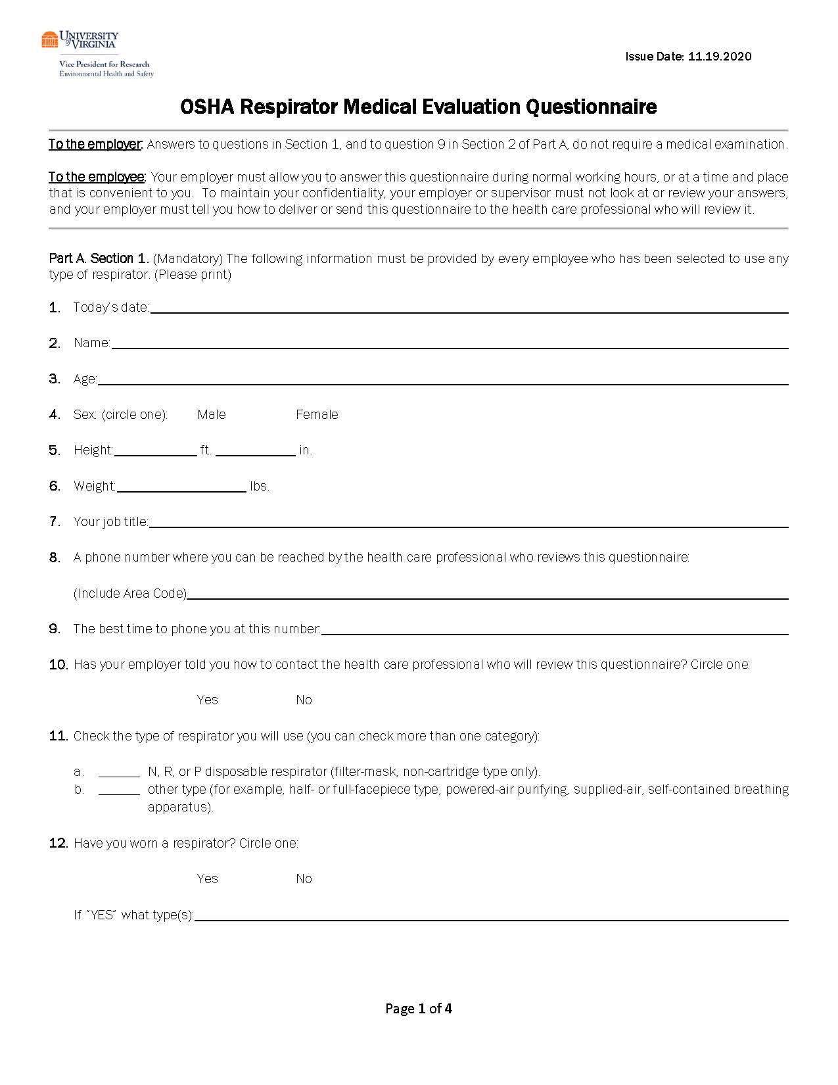
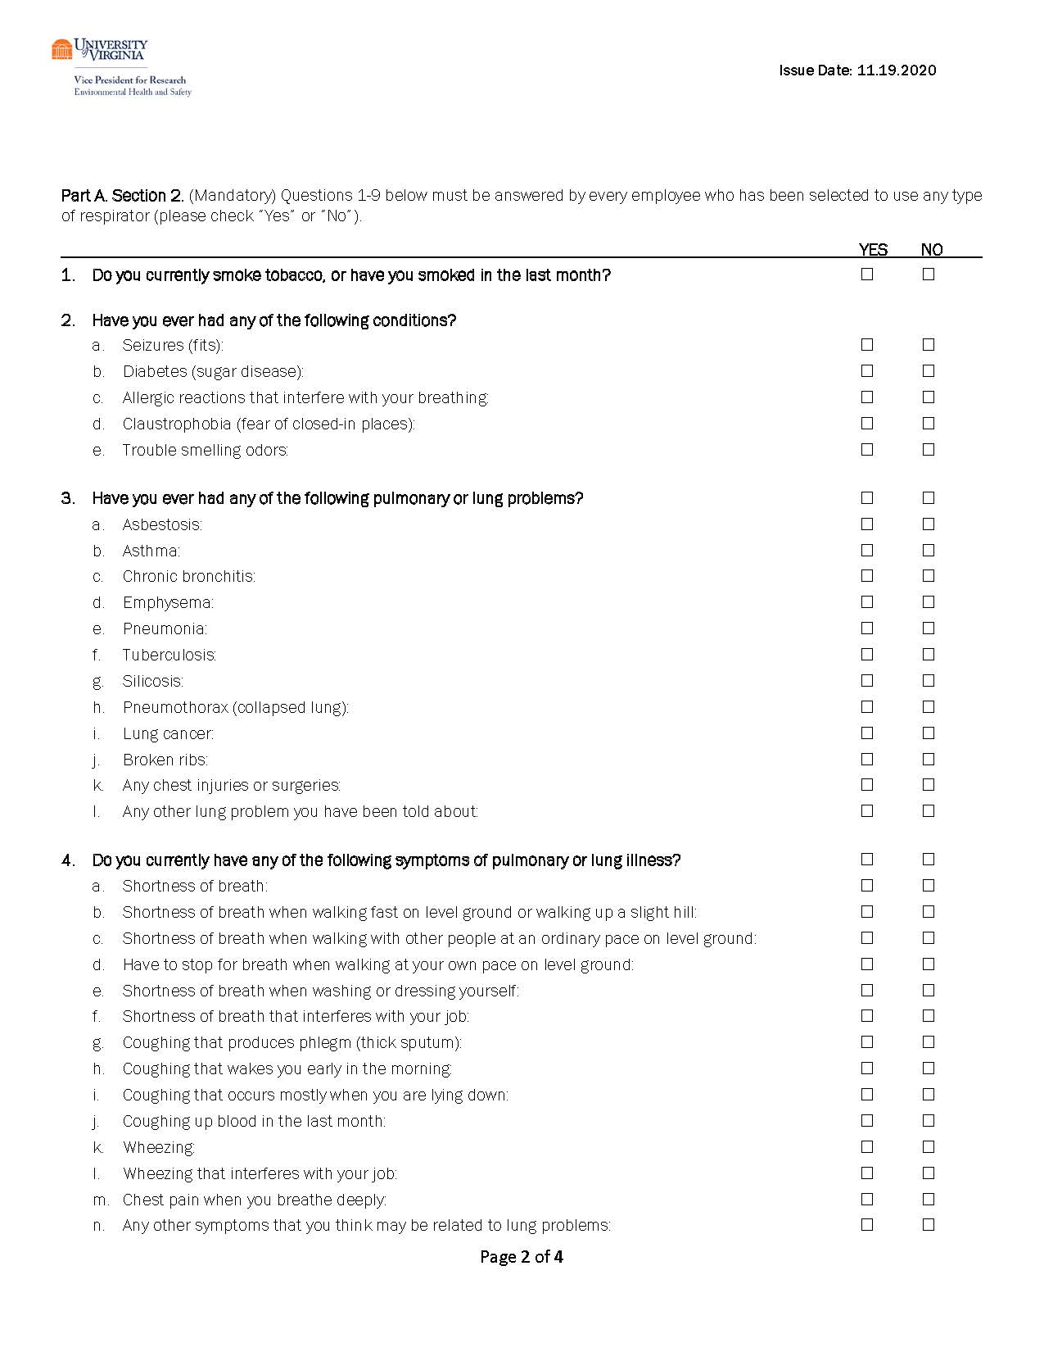
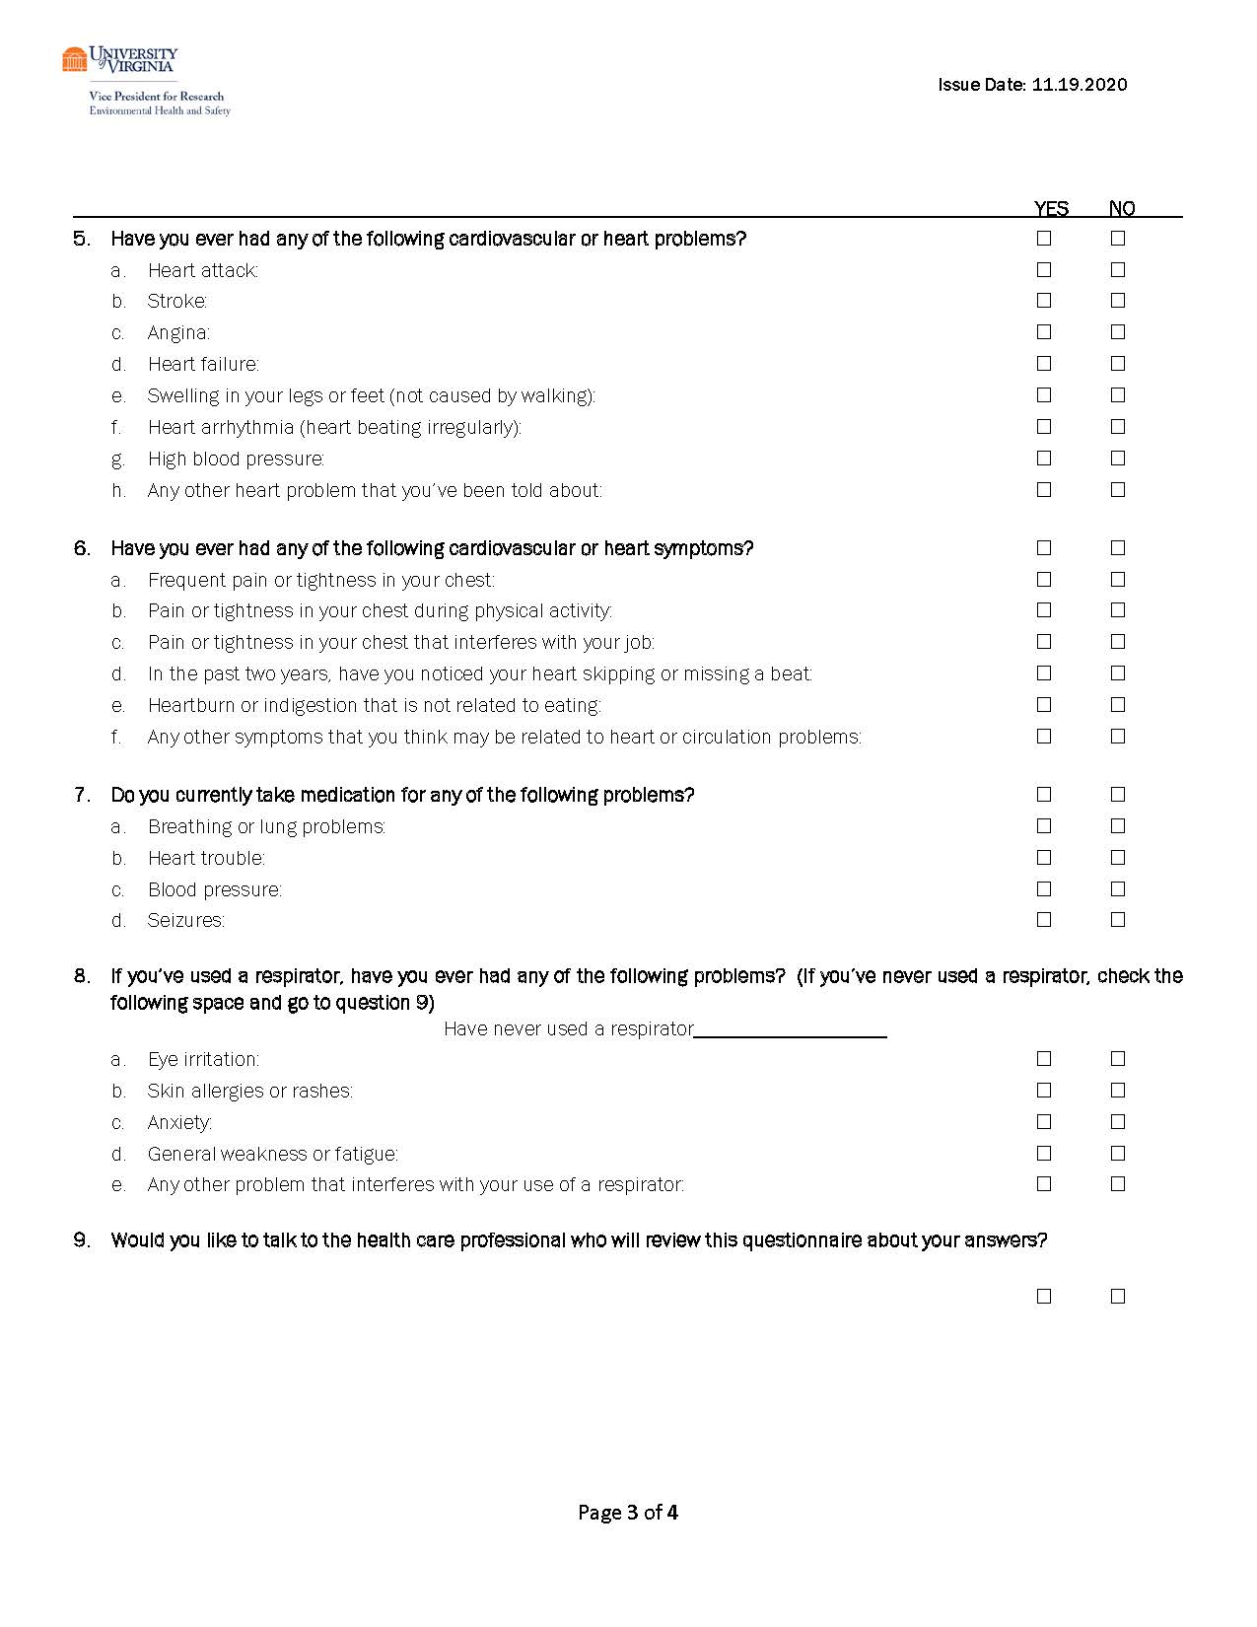
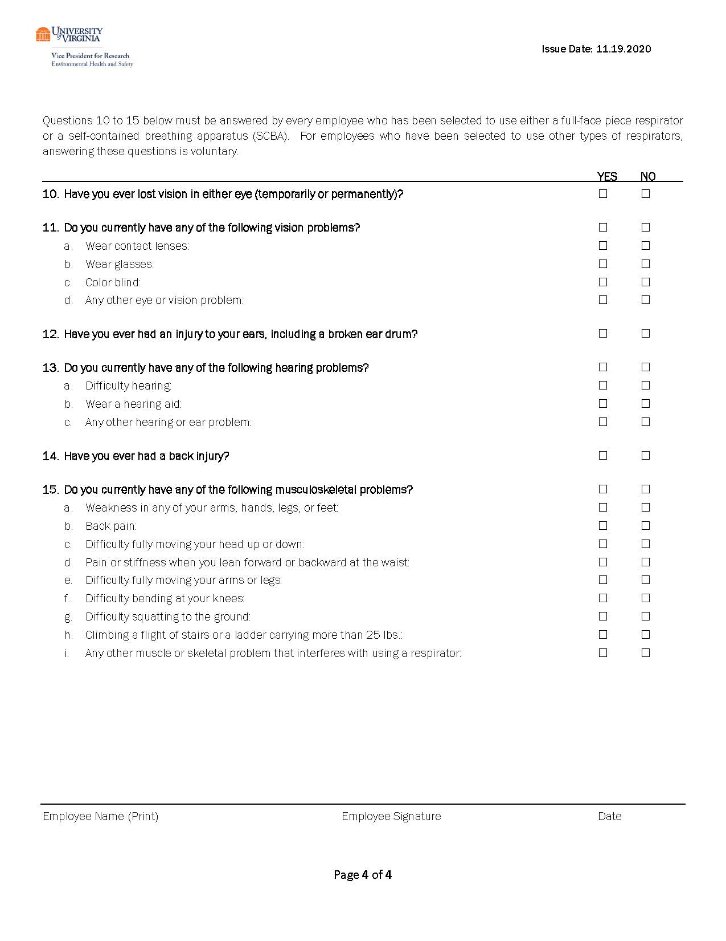

APPENDIX-D

Respirator Use Information Form
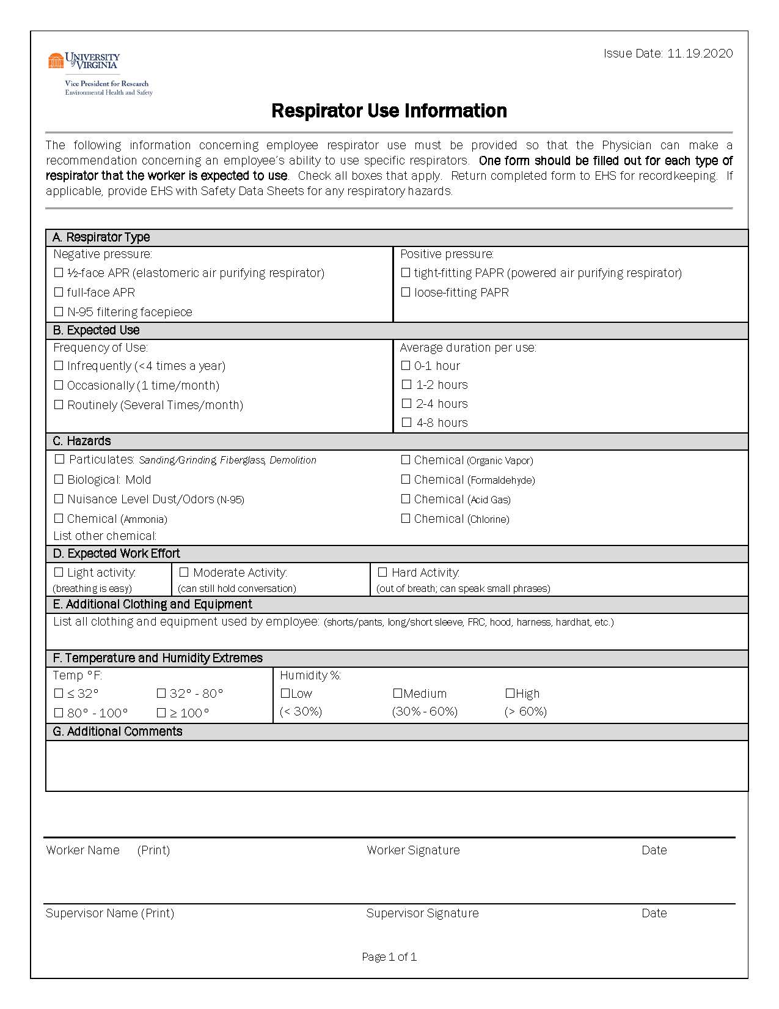

APPENDIX-E

Respirator Training & Fit Test Form

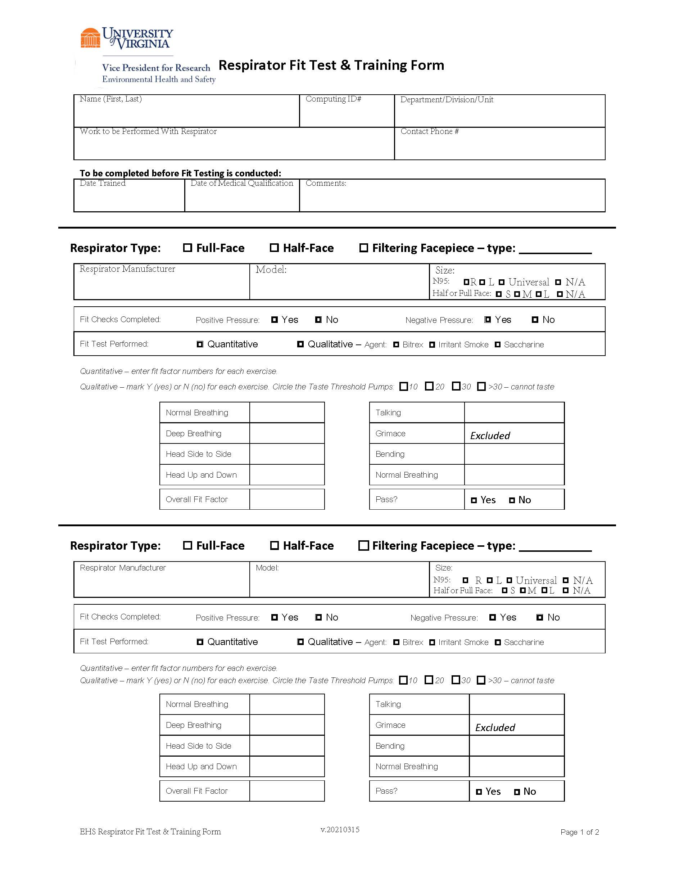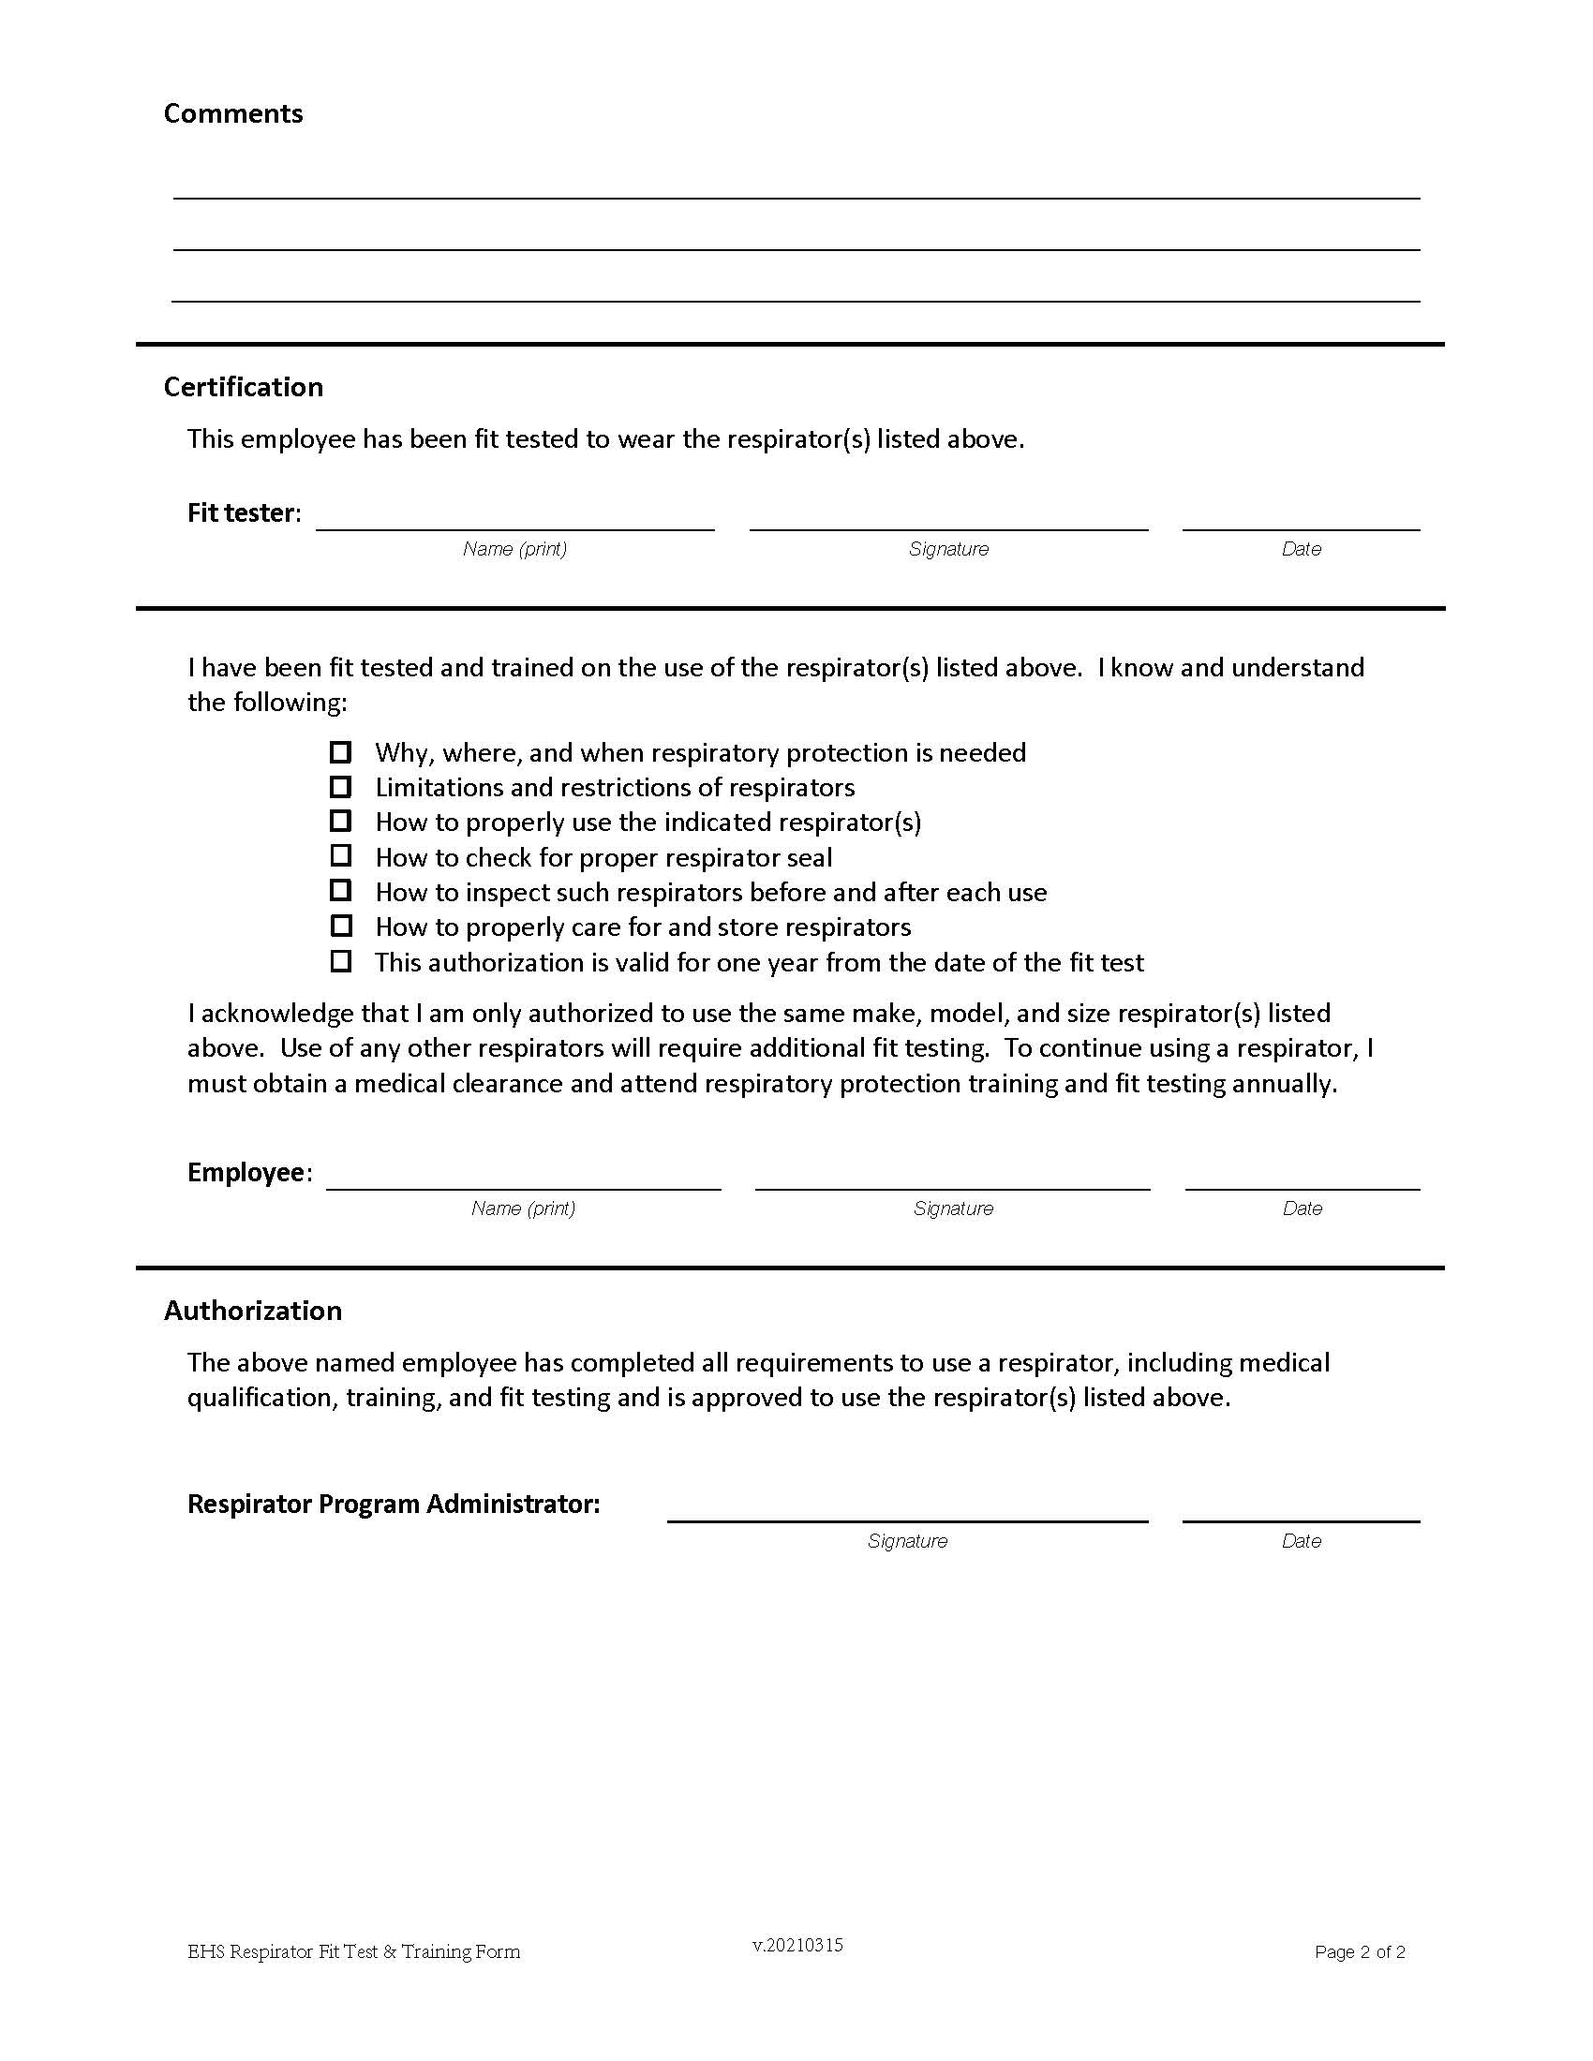

APPENDIX-F

Voluntary Use of Respiratory Protection Agreement

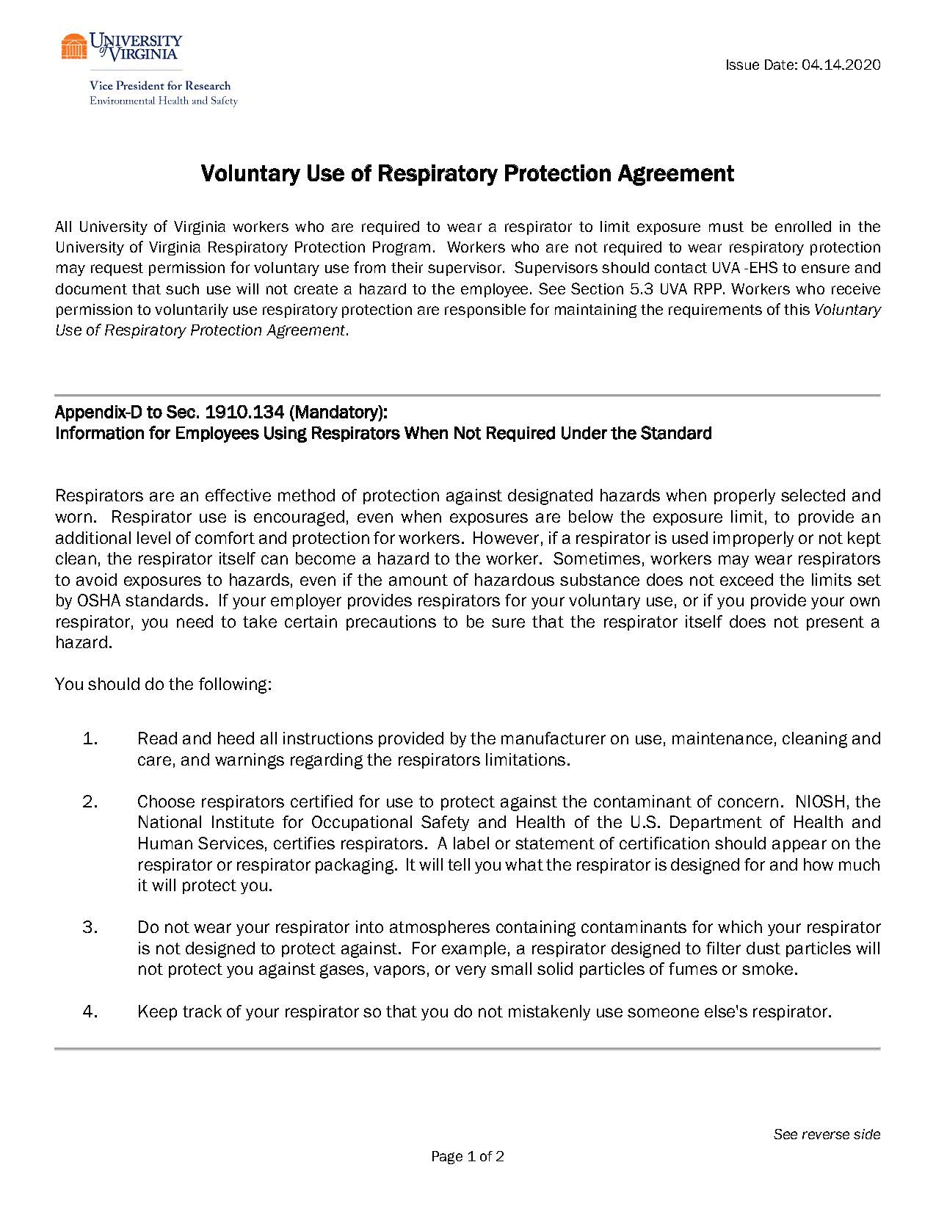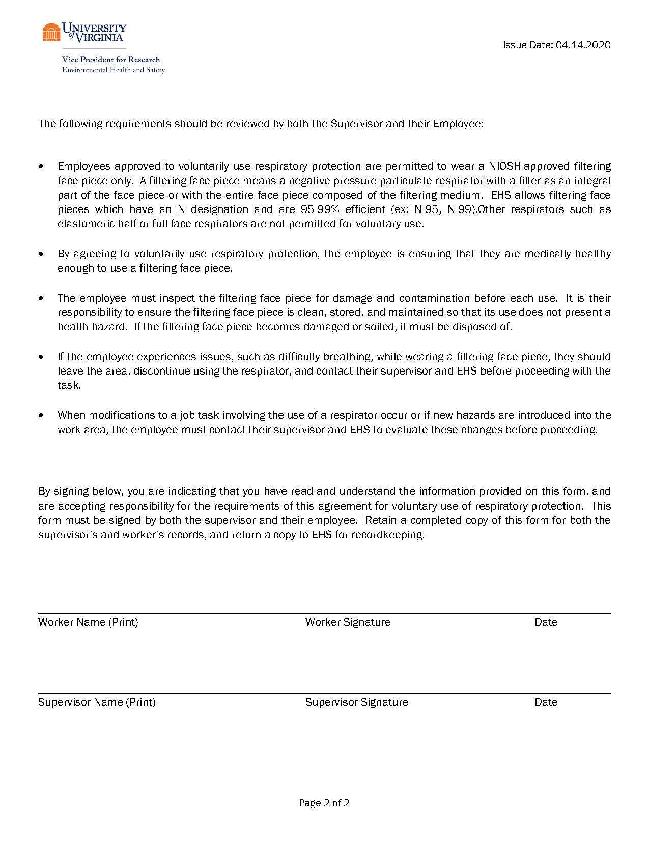

APPENDIX-G

Non-Mandatory

Research Project Specific Procedure for Use of Respiratory Protection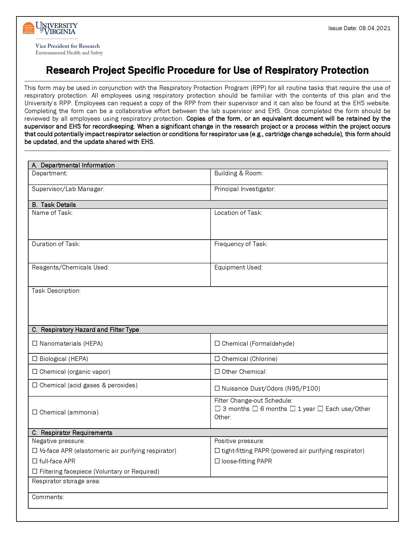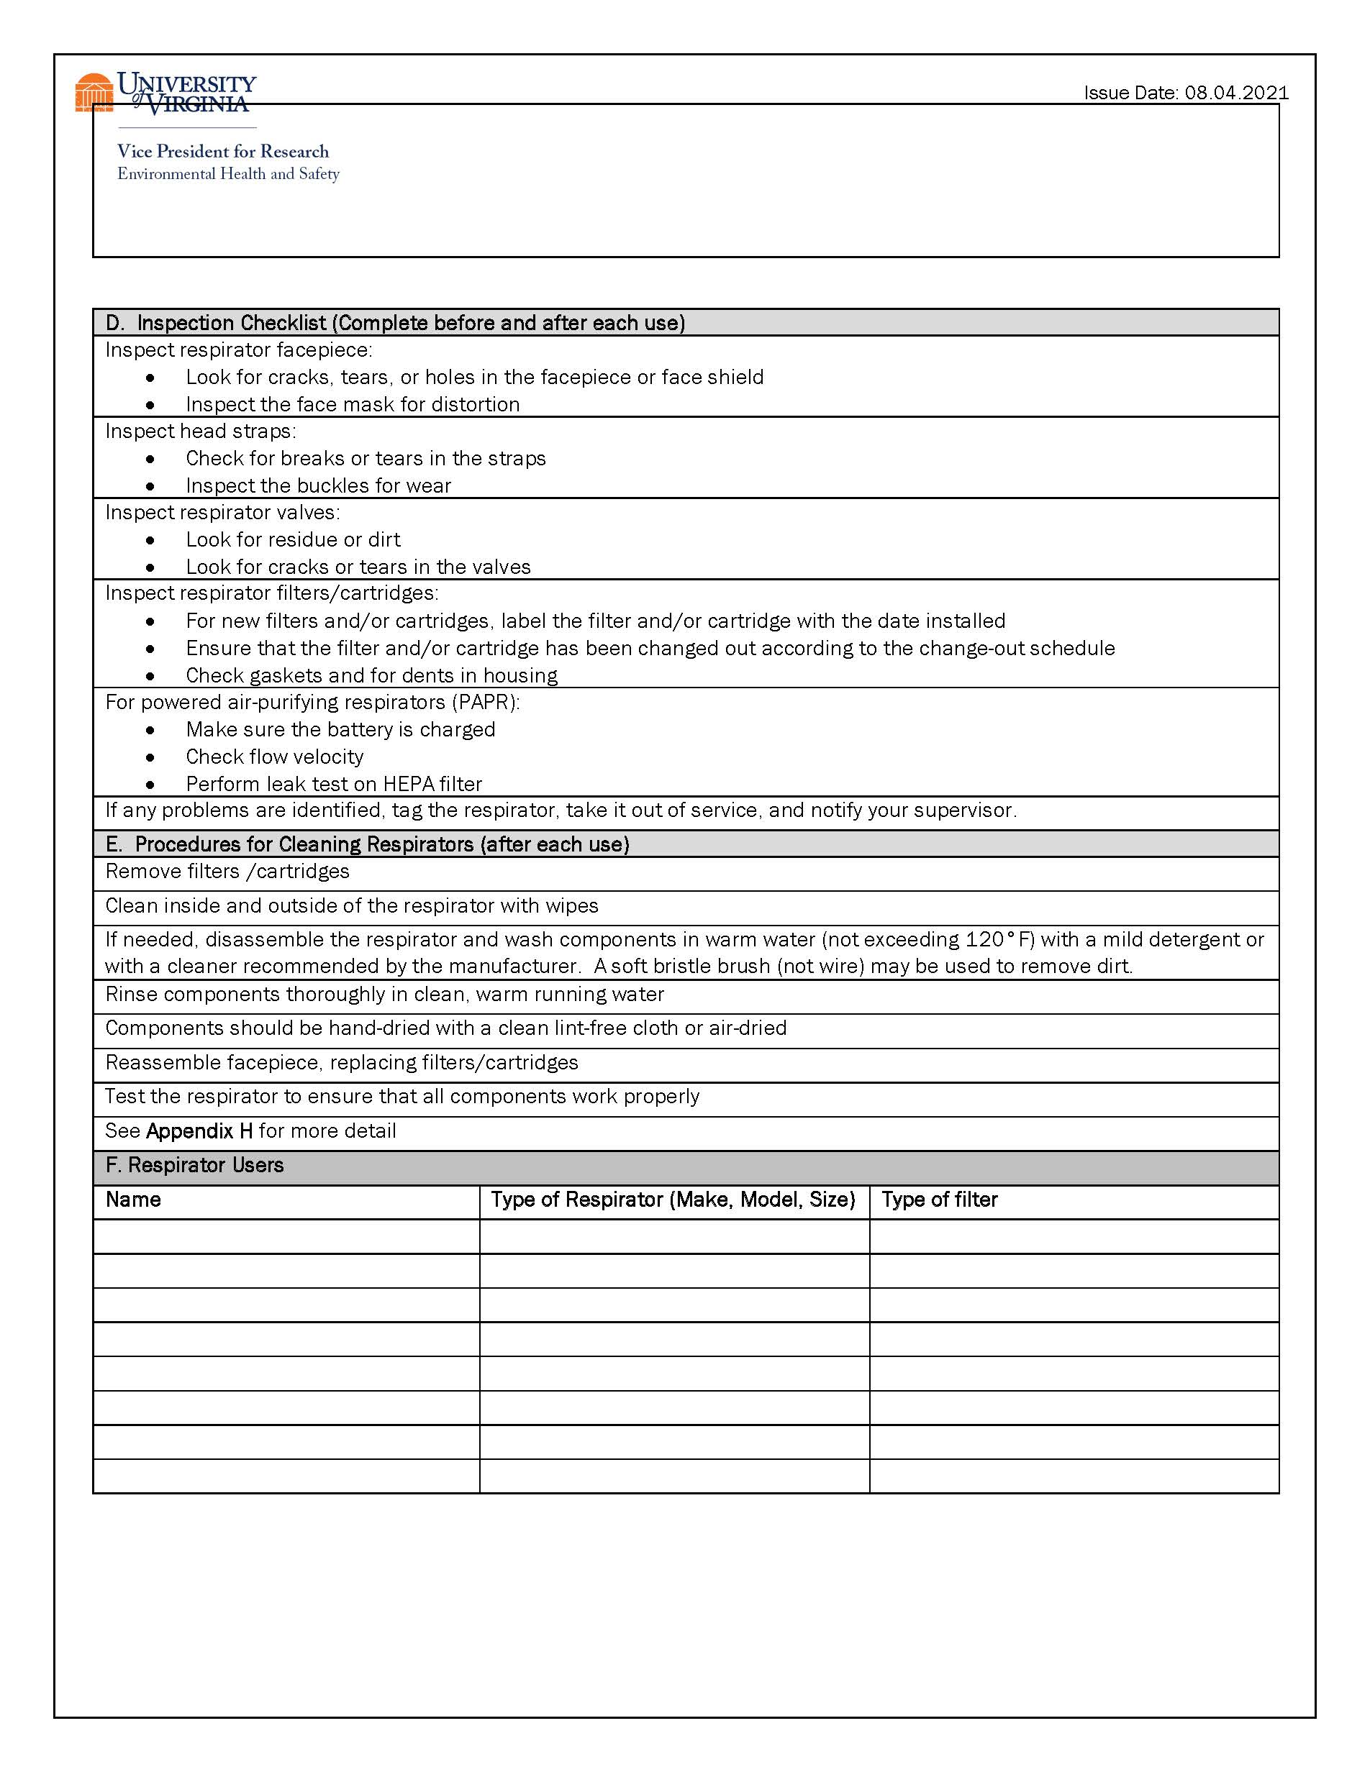
APPENDIX-H
Respirator Fit Testing Procedures

Fit Testing Procedures
Fit testing can be performed using either a quantitative or qualitative method. Quantitative fit testing is conducted by an EHS employee competent in using a Porta Count electronic device. The Porta Count fit testing device determines the fit factor based on the ratio of particle concentrations outside the respirator versus inside the respirator. Tubing connected to the respirator facepiece measures the particle concentration inside the facepiece while the ambient particle concentration outside the respirator is simultaneously measured by the Porta Count.
Qualitative fit testing determines fit by relying on the user to identify a test agent to indicate improper fit. This type of fit testing is performed by EHS and WorkMed. This method uses a gustatory (taste) test to indicate penetration or leakage of particles inside a fit testing hood. Prior to the fit test, applicants are tested for sensitivity to the non-toxic test agent to ensure valid test results. Either Saccharin or Bitrix (denatonium benzoate) are used for the test aerosol. Once users have verified sensitivity to the agent, both the respirator and fit testing hood are donned. The hood is filled with a high concentration of aerosolized test agent and a successful test is indicated if the user cannot taste the agent while wearing the respirator.
OSHA-approved quantitative and qualitative fit testing methods are described in 29 CFR 1910.134 Appendix A Fit Testing Procedures (Mandatory)
APPENDIX-I
Respirator Cleaning Procedures
Respirator Cleaning Procedure- Tight Fitting Respirators
Procedures for cleaning respirators (other than filtering facepieces) are specified in 29 CFR 1910.134 Appendix B-2, Respirator Cleaning Procedures (Mandatory), and includes the following:
- Remove filters, cartridges, or canisters.
- Disassemble face piece by removing speaking diaphragms, demand and pressure-demand valve assemblies, hoses, or any components recommended by the manufacturer.
- Full-Face Respirators: the center adapter, lens, and nose cup can also be removed if necessary.
- Wash components in warm water (not exceeding 120°F) with a mild detergent or with a cleaner recommended by the manufacturer. A soft bristle brush (not wire) may be used to remove dirt.
- After executing cleaning procedures, if needed, disinfect respirators e.g., COVID-19. Follow your department disinfecting protocol or manufacture’s disinfecting instruction. In general, use Oxyvir, Virex or Sani wipes (orange or purple). Surfaces must be visibly wet with disinfectant for the full specified contact time.
- Rinse components thoroughly in clean, warm running water
- Components should be hand-dried with a clean lint-free cloth or air-dried.
- Reassemble facepiece, replacing filters, cartridges, or canisters.
- Test the respirator to ensure that all components work properly.
- Place in a clean, dry, sealable plastic bag or other suitable container for storage after each cleaning and disinfection

Respirator Cleaning Procedure- PAPR’s
Procedures for cleaning loose fitting respirators include the following:
- Remove the filter/cartridge and breathing tube while each of those connections are facing down.
- The outer surfaces motor/blower assembly and battery pack may be wiped with a soft cloth dampened in a solution of water and mild, pH neutral detergent.
- Clean the connection sites on the breathing tube with the water and detergent solution. The breathing tube can be immersed in water for cleaning if required. The inside of the tube must be completely dried prior to use or storage. Air dry, or dry by connecting to the motor/blower unit and use it to force air through the tube until dry. Orient tube to prevent water from running into blower.
- Wipe or rinse all belts thoroughly and dry completely before next use.
- Clean headgear based on the headgear specific User Instruction and cleaning guides.
- Reassemble head gear, breathing tube, blower/motor and replace filters /cartridges.
- Test the respirator to make sure that all components work properly.
- Place in a clean, dry, respirator storage location after each cleaning and disinfection
- For loose fitting respirators with air inlet, outlet cleaning and storage plugs

Attach the air inlet and air outlet cleaning and storage plugs into the blower. The motor/blower can now be rinsed under running water or submersed in water. Water temperature should not exceed 122°F (50°C).

Remove battery and wipe down top of battery pack, if needed, with a soft dry cloth. If needed, the battery strap can be used to protect the pads during cleaning. With the strap in place, the battery can now be rinsed under running water or immersed.

Make sure the connectors are clean and dry prior to charging, installing on blower or for storage.

1910.134(d)(3)(iii)(B)(2) If there is no End of Service Life Indicator (ESLI) appropriate for conditions in the employer's workplace, the employer implements a change schedule for canisters and cartridges that is based on objective information or data that will ensure that canisters and cartridges are changed before the end of their service life. The employer shall describe in the respirator program the information and data relied upon and the basis for the canister and cartridge change schedule and the basis for reliance on the data.

